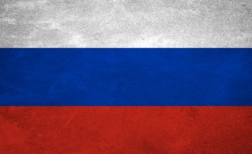 Climate Change 

Country: Russian Federation

Committee: United Nations General Assembly First Committee

Delegate: Ela Çetin

We all know that Russia is the one of the coldest countries on earth. This North Hemisphere country is located above the equator, and has several coasts to the North Pole. Due to the population and variety of territories in the country, climate change is an escalating concern for Russia.

Russia has one of the largest reserves of coal and oil gas, which makes the country as an leading energy producer. Industries that rely heavily on those fossil fuels.

In addition to that, we made a dialog with our friends. We asked: What do you think when you hear the country Russia? They all gave the same answer, that they think about the ice and the freezing winter. So, Russia’s one of the population stuff is winter. !!!

So, we got some ideas to stop the climate change:

1) Producing new public transportation vehicles, so we can save some gas and this is step 1 to stop the climate change!

2) Saving some water, some electric.

3) Use more renewable energy items (like electric vehicles)

Determined contributions it pledged that by 2030 it would limit greenhouse gases to between 70 and 75 percent of 1990 levels but it said it was dependent on how much CO2 its forests could absorb. Over the last few years it has disasters that some attributed to climate change. Devastating floods, wildfires, droughts, and soaring temperatures in 2010 that killed a lot of people.Now, we have to remember that Russia is the 4th largest emitter of CO2. So it has a lot of work to do. But perhaps the biggest problem for Russia is getting enough public support. Because there isn’t much desire from the top to make changes indeed. Russia’s media does not cover climate issues that much and Russia’s media does not cover climate problems that much. Russia’s top end boy on climate issues Alexander Petrovsky says Russia, Canada and fossil fuels, it’s even alleged! President of the Russian Federation Vladimir Putin believes climate change is something that’s been made up to curb Russia’s industrial development. And back in 2003, he said climate change would be helpful as Russians could spend less money on fur coats. President cares about animals, and with that now Russians care about animals too. So they think about the animals where on the pole. For example polar bears. Their fur is so good for fashion but as Russians care about them, they started to think that climate change is really scary and dangerous for them.