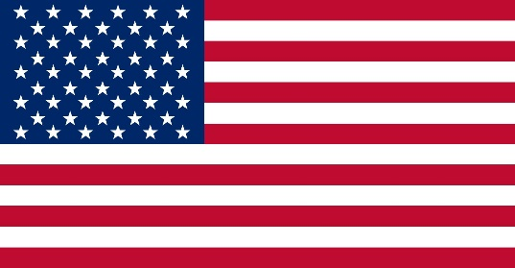 **Country**: United States of America

**Committee**: DISEC

**Agenda Item**: Regulating the Use of Private Military and Security Companies

**Delegate**: Zeynep EROL

United States, country in North America, a federal republic of 50 states. Besides the 48 conterminous states that occupy the middle latitudes of the continent, the United Statesincludes the state of Alaska, at the northwestern extreme of North America, and the island state of Hawaii, in the mid-Pacific Ocean. The conterminous states are bounded on the north by Canada, on the east by the Atlantic Ocean, on the south by the Gulf of Mexico and Mexico, and on the west by the Pacific Ocean. The United States is the fourth largest country in the world in area (after Russia, Canada, andChina). The national capital is Washington, which is coextensive with the District of Columbia, the federal capital region created in 1790.

The private military and security companies can be easily called beneficial for the productivity and reliability in conflicts and securing actions. These companies are mainly known to guard the civil society, maintain weapons, improve the local military, protecting individuals or communities, etc. Right after the combat in Iraq, Afghanistan, former Yugoslavia, and Syria, the US private military decided to also protect the airports, escort international organizations’ humanitarian convoys and train the foreign armies. Despite having many co-operations with the private military, The United States does not have a fully equipped laws about it. Still, they are indirectly regulated by the Arms Export Control Act. “The International Convention against the Recruitment, Use, Financing and Training of Mercenaries, which came into effect in 2001 (the United States has not signed it), does not include these companies and their employees. It is also possible to prosecute the security companies in US jurisdiction.” About the death or injuries for whom working in these companies, the general rules of insurance in force apply to them very much the same. The United States of America is firmly known to hold private military and security companies. One can be exampled as Blackwater, which was employed up to 150,000 people around the world and had a great amount of training bases, helicopters, weapons and special equipments. Mentioning all these, it is easily stated that the United States of America is close enough to the idea of expanding and developing the management of the private military and security companies.

Regarding all these information mentioned, it is beneficial to offer a few ideas in order to expand the cooperation with military and security companies without any loopholes and inconveniences. It is essential to understand that the insufficiency of international or national laws about the companies lead to misusage of the power and violation of human rights by harming civilians which also may end with the death of them. That is why it is important to take actions on legal frameworks internationally. This can be reached by having new international legislative actions by benefiting from the LEGAL committee about restricting the exploitation during duty and protecting the human rights by observing the companies thoroughly. Moreover, regulating the PMSC’s (Private Military and Security Companies) by registrating and authorising them will lead to the better detection of their actions, which will also provide the transparency that is needed between countries. Lastly, encouraging the member states to participate to the Montreux Document since it is helpful to keep the cooperation fast and active since it is important to work sufficient and convenient internationally.

**BIBLIOGRAPHY**

<https://www.britannica.com/place/United-States>

<https://www.mid.ru/en/foreign_policy/international_safety/regprla/1896217/?TSPD_101_R0=08765fb817ab20001a08386edcfb9288981a2e10da4e721880200517e9c0a137f8687c82d75466ac0805da447714300023c9673f4517cc0b2502d4f8ed983d0cb3b7c6e9e60cd8c1449eaf56045af61df10c5e7c262c759dc9a1e9d74c2bdcd1>