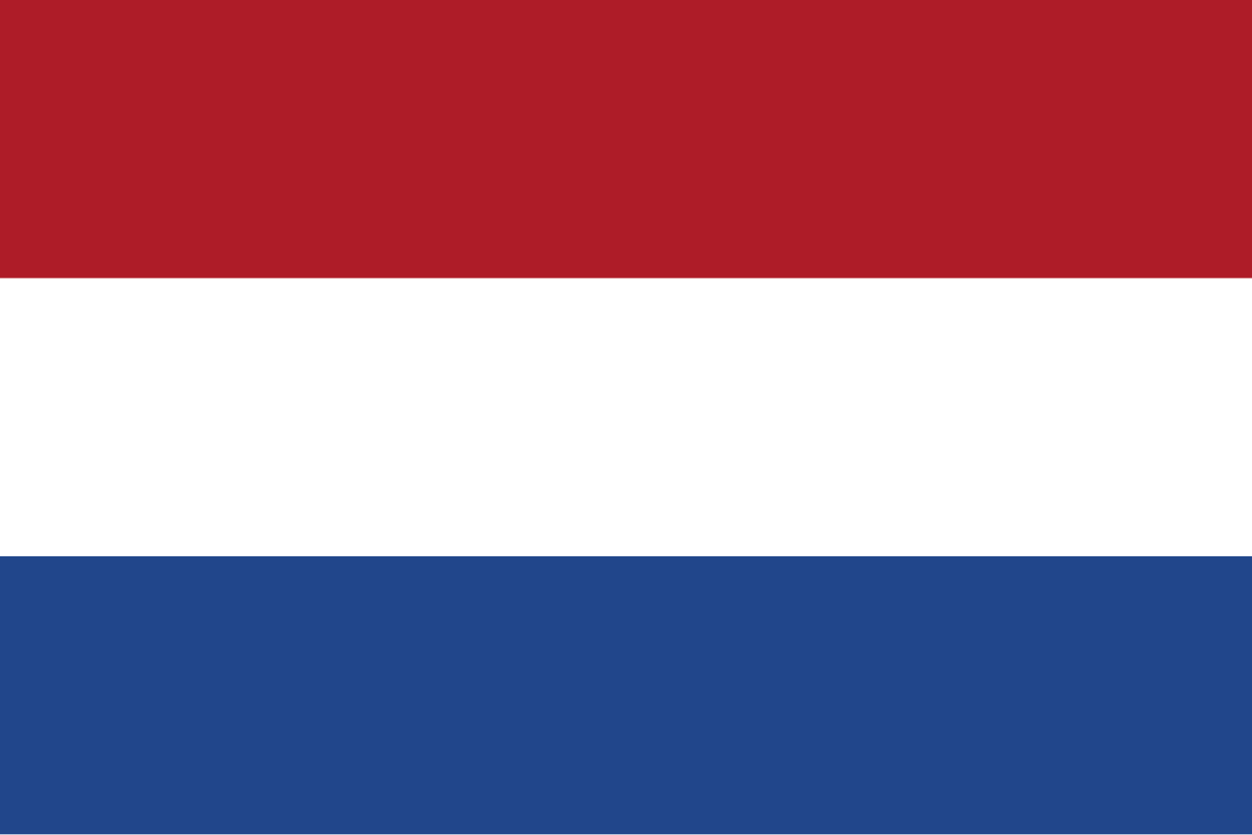
POSITION PAPER
Country: Netherlands
Committee: SPECPOL (The Special Political and Decolonization)
Agenda Item: Decolonization in the 21st Century:Addressing the Challenges of Non-Self Governing Territories
Decolonization is the process of colonies gaining independence and self-governance from colonial powers and it is one of the most dedicated subjects that the Special Political and Decolonization Committee (Fourth Committee of the General Assembly) deals with.Non-Self-Governing territories are terrorities that are identified by the United Nations as not having full self-governance or independence. There are currently 17 territories listed as Non-Self-Governing Territories (NSGTs) according to the United Nations. These territories are mostly small islands facing challenges such as rising sea levels, limited natural resources, and economic dependency on other governments. Decolonization aims these territories to achieve self-governence and independence.
The UN has taken many precautions to decolonize the Non-Self Governing Territories. In 1960, the General Assembly adopted the Declaration on the Granting of Independence to Colonial Countries and People.In the following year, a special committee on decolonization called C-24 has been established by the United Nations. This committee has been doing referendums on self government. The UN also maintains a list of NSGTs and receives annual reports from administering powers on the political, economic, and social conditions of these territories. With the help of these actions, the UN has contributed to the independence of more than 80 countries since its founding. However, 17 territories remain on the NSGT list, and the UN continues its efforts to help them achieve their independence. The Netherlands emphasizes legal frameworks for self-determination and decolonization guided by UN. It has participated in discussions and supported decisions on the remaining Non-Self-Governing Territories globally.
The Netherlands was a major colonial power in the past, possessing large territories, notably Indonesia, Suriname and the Caribbean. However, by the mid-20th century, with increasing intermittent movements, particularly after World War II, the Netherlands began to recognize the periods of its colonies.Netherlands currently supports the right of people in NSGTs to choose their own political status, whether through independence. The country engages in democratic processes like they did in Aruba and the Netherlands Antilles referendums.
Additionally, the Netherlands works closely with the UN's Special Committee on Decolonization, advocating for peaceful and cooperative solutions.
To decolonize the remaining 17 NSGTs, Political Status Referendums should be done in these territories to allow the territories to choose their own political status. The United Nations can apply international pressure on governing states to fulfil their protections from colonialism under international law. This ensures that governing powers respect the rights of local peoples and support their efforts for self-sharing.Moreover, The International Court of Justice(ICJ) can provide legal clarity on issues such as international recognition, the right to self-determination, and the responsibilities of governing powers. UN High Commissioner for Human Rights (OHCHR) can prepare a technical help plan and makes sure that people in NSGTs have their human rights, including the right to self-determination and freedom from discrimination.

