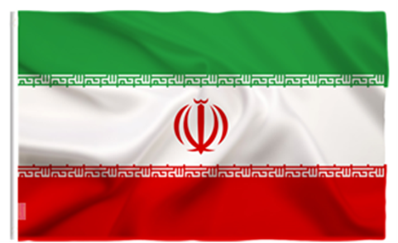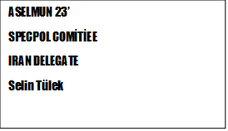

Historically, Iran and Somalia have signed agreements on trade, economic cooperation, and cultural exchanges. Iran has provided humanitarian aid to Somalia during times of crisis, including sending aid ships carrying food and medical supplies to support drought-affected areas. Iran has also supported development projects in Somalia, particularly in the areas of infrastructure, healthcare, and education. Additionally, Iran has offered scholarships to Somali students, enabling them to pursue higher education in Iranian universities. The cultural exchanges between the two nations have included events such as art exhibitions, cultural festivals, and academic collaborations. Iran has also cooperated with Somalia and other regional actors to combat piracy in the waters off the Somali coast, sharing intelligence and participating in joint naval patrols.
Iran began its relations with the Horn of Africa after the 1979 Islamic Revolution in Iran, but the desired closeness was during the period of Iranian President Mahmoud Ahmadinejad, who was in power in 2005. The Red Sea and the important straits and ports in this region are the major waterways used by Iran to export oil and military equipment to radical Islamic groups. In addition, the uranium needed for nuclear power is supplied from the Horn of Africa. At the same time, Shi'ism is one of the important foreign policy instruments that Iran is trying to use in this region.
In 07.01.2016 a problem has arisen As a result of the attack on Iran's embassy in Tehran, Iran had diplomatic problems with Saudi Arabia. During these events, Somalia declared that it was on the side of Saudi Arabia and broke off diplomatic relations with Iran. Also Iran allegedly aided terrorists in Somalia. Of course it was a false accusation.
Iran, like other nations, has expressed its commitment to combating terrorism and promoting regional stability. It is essential to consider the specific evidence and context surrounding any accusations made against Iran. Assessing the involvement of external actors in Somalia's security situation requires a comprehensive understanding of the complex dynamics at play, involving a multitude of factors and actors.
Iran has engaged in diplomatic efforts to support Somalia and promote stability in the region. It has contributed to diplomatic initiatives in several ways. Firstly, Iran has participated in regional forums and organizations such as the African Union (AU) and the Intergovernmental Authority on Development (IGAD), which play significant roles in addressing political and security challenges in Somalia. By actively engaging in these platforms, Iran has contributed to discussions, negotiations, and cooperative efforts aimed at finding peaceful solutions to the conflicts in Somalia.
Secondly, Iran has been involved in facilitating dialogue and reconciliation processes in Somalia. It has used its diplomatic channels to encourage and support efforts for peace and stability. This can involve hosting meetings, providing mediation support, and acting as a facilitator between conflicting parties. By actively engaging in diplomatic channels, Iran has worked towards promoting dialogue, understanding, and reconciliation in Somalia.
Furthermore, Iran has been vocal about supporting Somalia's sovereignty, territorial integrity, and the rights of the Somali people. It has expressed its commitment to non-interference in Somalia's internal affairs and emphasized the importance of national unity and self-determination. By advocating for these principles, Iran has sought to contribute to Somalia's diplomatic relations and stability.
Nowadays seven years later, it is foreseen that diplomatic relations with Somalia will be re-established as a result of the meeting of Saudi Arabian and Iranian diplomats in Beijing and the improvement of relations between them.
In the future, Iran can potentially contribute to Somalia in various ways. It can continue providing humanitarian aid during times of crisis, supporting development projects in infrastructure, healthcare, and education, and offering educational opportunities to Somali students. Iran can also engage in capacity-building efforts to enhance governance, security, and counterterrorism capabilities in Somalia. Additionally, Iran can play an active role in diplomatic initiatives, promoting peace, stability, and reconciliation in the country. By aligning its efforts with the needs and priorities of Somalia, Iran can contribute to its long-term development and the well-being of its people.

