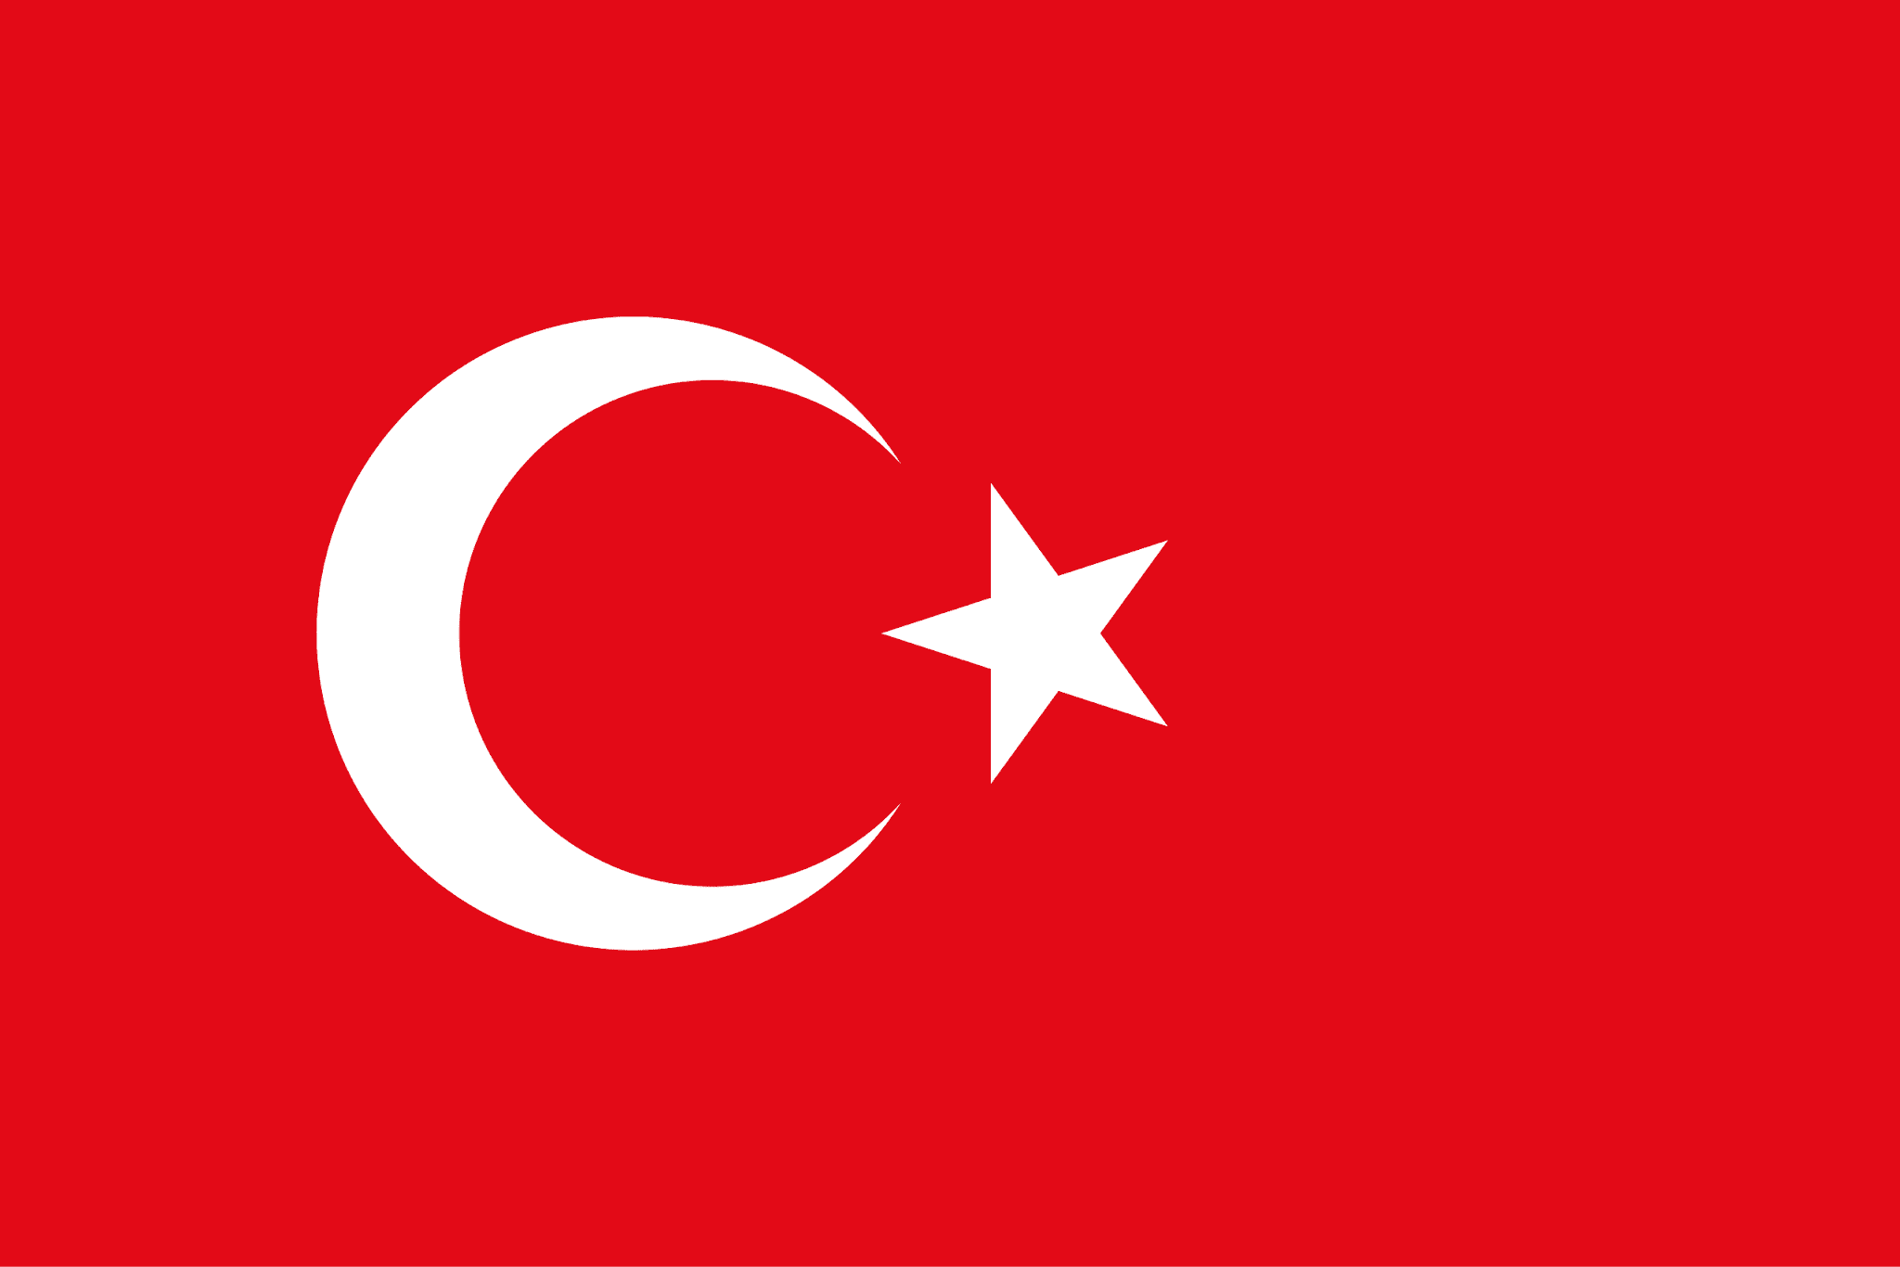
Committee: NATO

Country:Turkey

Agenda Item: Addressing the Strategic Implications of China’s Expanding Global Influence

Delegate: Gülseren Ercan, Özel Tema Koleji Bağlıca

The Republic of Turkey is situated in southeastern Europe and southeastern Asia by playing a major role as a bridge and a connection between many regions. It is surrounded by 3 different seas and has a population of about 80 million.With our strategic geopolitical position we provide other nations to exchange needed resources,trading and different cultures in economical and political spheres. We cooperate among nations as a participant of NATO,a founding member of the United Nations as well as the Council of Europe and the G20.
The government reforms to expand the access to affordable and high quality healthcare through the Universal Health Coverage system ensuring to all citizens needed medical services. In the field of education an increasing number of universities recognized internationally and a new education system offered in process for developing better knowledge and bringing creativity to students.Turkey is challenging high inflation and a trade deficit but still stays as one of the largest market economies in the Middle East.

Nowadays China has grown very quickly and become one of the most powerful countries in the world. This rise has made a good threat for the world and affected many parts of international politics but especially for NATO. China is not only powerful because of its economy but also because of its diplomacy,strength military and developing technology.
In our past actions Turkey has maintained diplomatic alignment while hedging by pursuing a strategic autonomy. We are a member of NATO but still keeping ties with Western allies while also engaging China.
Turkey is aware of the risks of becoming dependent on China economically so we adopted measures such as tariffs and seeking diversification of trade partners. We also imposed anti-dumping duties on steel imports from China. We are also in the process of developing our own technologies for defense and our own capacity to avoid locking into one dominant partner like China. By taking a multi-pronged strategy we also engage with China infrastructurally and taking advantage of many opportunities.

As the delegation of Turkey we suggest some solutions to building a balanced global approach to keep the international system open,equitable and stable for all the countries. We encourage open communication between China and other major powers in order to reduce mistrust and misunderstanding among us. Many countries like us are worried about becoming dependent economically on China so we propose to develop partnerships with other economies like EU,ASEAN,.. to reduce dependence on one power. As a NATO member we must strengthen regional security dialogues and support peaceful conflict resolution to protect our security. Finally we would like to create some alternative financing options to support developing nations that struggle during China’s expanding global influence.

