Committee: United Nations Development Program 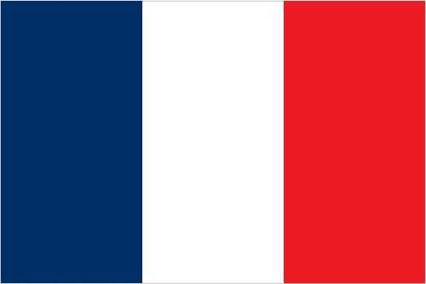

Agenda Item: Production of Sustainable Biomass Energy

Country: French Republic

Delegate: Duruşah Curacı, Özel Bağlıca Tema Koleji Anadolu Lisesi

Southeast of the United Kingdom, in Western Europe, between Belgium and Spain, is France, formally known as the French Republic. Covering 551,695 square kilometers, it is home to more than 67 million people and features a variety of landscapes, including the Alps and the Mediterranean coast.France has the third-biggest economy in Europe, behind Germany and the United Kingdom, and the seventh largest economy in the world because to its robust industrial, pharmaceutical, and tourism industries.

Acknowledging the sector's significance and potential, France introduced a National Strategy for the Mobilization of Biomass in 2018. In France, biomass is the primary renewable energy source and is essential to sustainable development. The bioenergy sector produced 7.7 TWh of power in 2018, accounting for 21% of France's total electricity production from renewable sources. More than 50% of renewable energy was produced in 2019 using bioenergy, primarily for heating.The majority of bioenergy is generated from domestic waste. Conventional biofuels account for 7% of fuel energy in France. Biomass energy continues to be the most popular renewable energy source in France, despite not being the most talked about. By 2030, France wants to cut its emissions by 55% from 1990 levels. By 2027, the nation's two 1.8GW coal-fired power facilities will be converted to biomass, according to President Emmanuel Macron.

France firmly thinks that renewable energy is essential for sustainable development and is in favor of producing electricity from biomass. We believe that in order to guarantee that future generations live in a pollution-free environment, we need to take some action as soon as feasible. We think that in order to help developing nations to have more sustainable energy sources, we must financially assist them.