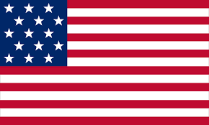
Committee: The Security Council
Topic: Azerbaijan and Armenia War
Country: United States of America

It is known by all countries that this conflict, which has been going on since February 20, 1988, has created difficulties and problems for both Armenia and Azerbaijan. It is our greatest wish as the United States of America that this long-standing Nagorno-Karabakh dispute will be resolved without further wars and turmoil.
The US is allying with both of the counties. This includes supporting Armenia's efforts to achieve peace in Nagorno-Karabakh, reopen its closed borders with both Azerbaijan and Turkey, as well as regional development. Aside from that, we firmly support the OSCE Minsk Group Co-Chairs in their efforts to find a long-term and sustainable political solution to the Nagorno-Karabakh conflict in order to foster regional stability. A peaceful resolution to the Nagorno-Karabakh conflict through the Minsk Group process is still a priority for the United States. Neither the international community nor the United States recognizes Nagorno-Karabakh as an independent country. Azerbaijan's territorial integrity is supported by the United States, which believes that the future status of Nagorno-Karabakh should be negotiated between the parties in order to achieve a durable and comprehensive political settlement of the conflict.
The United States includes funding for housing and school repairs, primary health care (including irrigation), potable water (including sanitation), subsistence agriculture (including microfinance), and demining (including the removal of landmines). As always, we are ready to provide them in both countries if needed.
We believe that this cruel conflict must end as soon as possible. As a country that believes that both countries have made mistakes in the past, we think that the past should be left behind and the counties must find peace in a reasonable way. In our point of view, we believe that peace and finding a middle ground is one of the best possible solutions to this ongoing issue. We as the delegate of the United States of America would like to have both related countries cease-fire.

