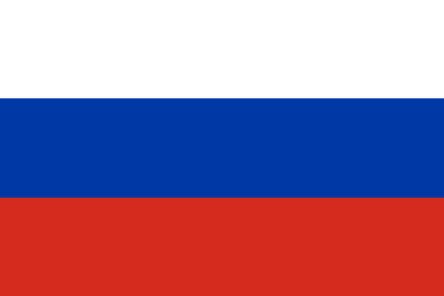
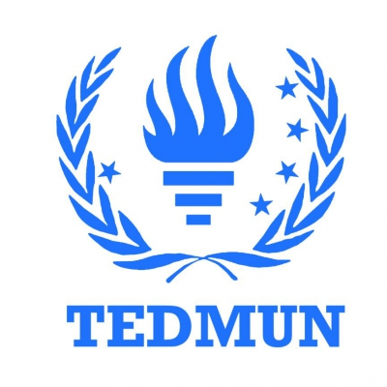
Committee: UNSC
State: Russian Federation
Agenda: Belarus Border Conflict
Delegate: Kemal Can Filorina

“History proves that all dictatorships, all authoritarian forms of government are transient. Only democratic systems are not transient. Whatever the shortcomings, mankind has not devised anything superior.”
-Vladimir Putin, President of Russian Federation

Before we, as Russian Federation, begin addressing our deep concern and policies for the issue regarding Republic of Belarus, surrounding countries and other members of United Nations Security Council, we would like to put forth that we will reassure that our policies and beliefs will be absolutely aligned with the decisions, as conclusions, made in the video conference of the members of the European Council on 19 August 2020:
- The members of the European Council discussed the situation in Belarus following the presidential elections on 9 August.
- The EU has been following the developments in Belarus very closely and with increasing concern. The 9 August elections were neither free nor fair; therefore we do not recognise the results.
- The people of Belarus have a right to determine their future. The members of the European Council express their clear solidarity with the people of Belarus in their desire to exercise their fundamental democratic rights.
- The members of the European Council condemn the disproportionate and unacceptable violence displayed by the state authorities against peaceful protesters. Violence must be avoided and all those unlawfully detained must be immediately and unconditionally released. Civil society and opposition actors engaged in discussions of political transition must be protected from arbitrary arrests and violence. The EU expects a complete and transparent investigation into all alleged abuses.
- The EU will shortly impose sanctions against a substantial number of individuals responsible for violence, repression and the falsification of election results.
- Progress made in the past years in the relationship between the EU and Belarus is at risk. Any further deterioration of the situation will impact on our relationship and have negative consequences.
- We call on the Belarusian authorities to find a way out of the crisis through an end to violence, de-escalation, and an inclusive national dialogue. Only a peaceful and democratic process, underpinned by independent and free media and a strong civil society, can provide sustainable solutions. All parties, including third states, should support such a process.
- We will continue to follow the situation closely and stand ready to contribute to efforts to peacefully end the crisis. The EU fully supports OSCE proposals for dialogue in Belarus and is ready to provide assistance to further them.

On the other hand, as we understand our most crucial role in the issues raised from the conflict, we will not let Belarus, one of our most important economical partners outside of EU and other international organisations to take diplomatically illiterate actions as it could end up damaging the economical relations of Russian Federation greatly especially in Eastern Europe. For this reason and our historical bond with Belarus, we will also put forth some articles from the Contract between the Russian Federation and Republic of Belarus on friendship, neighbourliness and cooperation that we will follow and convince Belarus to follow as well:
- considering that further strengthening of friendship, neighbourliness and mutually beneficial cooperation is equitable to radical interests of the people of both states, serves cause of peace and safety,
- aiming to give new quality to the relations and to strengthen the legal basis of cooperation taking into account deep political and economic changes in both states and tendencies of the international life,
- confirming the commitment to the purposes and the principles of Articles of organization of the United Nations, provisions of the Helsinki Final Act, the Parisian Charter for new Europe and other documents of Organization for Security and Cooperation in Europe,
- in view of obligations of both states within the Commonwealth of Independent States,
Agreed as follows:
...Article 2: Contracting parties will closely cooperate for the purpose of preservation of peace, strengthening of stability, regional and global security...
...Article 4: Contracting parties in the conditions of openness of border between the Russian Federation and the Republic of Belarus will perform on the borders with the third states proper measures on safety of each other and to cooperate on the basis of free standing agreements in the decision between them boundary questions...
The Belarus Border Conflict has threatened such articles, and as mentioned, has taken the interest of UN as the conflict continuous to rapidly grow into a bigger threat. Being the closest partaker in this issue, the Russian Federation has an immense responsibility to keep its allies safe and make sure that Belarus does not take actions that could break the equilibrium of all Eurasia countries along with the fact that it would create a gateway for other threats to enter this territory and more.
As of today, Russian Federation holds the power of diplomatic and economic relations worldwide with being the fifth largest diplomatic network since 2019, with the exception of 2 years being the 6th. It maintains diplomatic relations with over 190 United Nations member states, four partially-recognised states, and three United Nations observer states; along with 144 embassies. Russian Federation is a member of the G20, the OSCE, and the APEC, and also takes a leading role in organisations such as the CIS, the EAEU, the CSTO, the SCO, and BRICS. Russian Federation has world largest proven gas reserves. And finally, as we must mention with utmost honour, Russian Federation is one of the P5 members of UNSC.
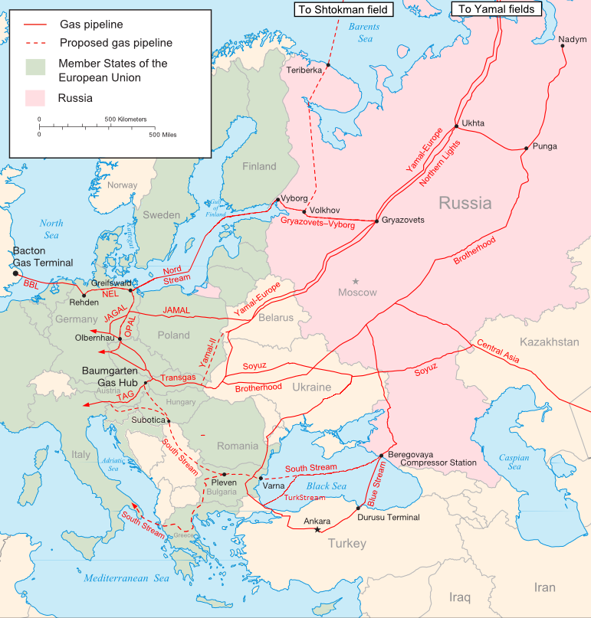
Russian Federation’s main economical strength comes from its extremely rich energy supplies. We have the world's largest proven gas reserves, the 2nd largest coal reserves, the 8th largest oil reserves, and the largest oil shale reserves in Europe. Russian Federation is also the world's leading natural gas exporter, the 2nd largest natural gas producer, and the 2nd largest oil producer and exporter.
In 2013 the shares of Russian natural gas in the domestic gas consumption in the EU countries listed were:
- Estonia 100%
- Finland 100%
- Latvia 100%
- Lithuania 100%
- Slovakia 100%
- Bulgaria 97%
- Hungary 83%
- Slovenia 72%
- Greece 66%
- Czech Republic 63%
- Austria 62%
- Poland 57%
- Germany 46%
- Italy 34%
- France 18%
- Netherlands 5%
- Belgium 1.1%

Being concerned by the “Milk War” and such political and economical disputes between Russian Federation and Belarus, we also want to clarify the fact that Belarus can only reach greater welfare and peace under the economical and political jurisdictions of Russian Federation. We will not change our policies for Belarus if they choose to go against our decisions made in the past; instead, we will lead UNSC to stabilize the unstable influx of “migrates”, the human rights concerns and the economical recession of Belarus. Our decisions, as mentioned before, will be in favour of UN decisions about the conflicts regarding Human Rights and threats to other countries. Then we will make sure that the people of Belarus are safe in the hands of possible assigned UN forces, which Russian Federation will only accept such interference under the regulation that Russian forces will be in lead. We believe that any action taken without the aid or possibly lead of Russian Federation will not be able to thoroughly solve the issue and won’t be made for the safety of international peace, especially from Middle East to Eurasia.
For this matter, we underline the important notice that Belarus’s current president Alexander Lukashenka has taken deranged steps which is abruptly deteriorating Belarus’s relationships with UN countries, Russian Federation along with other states in Russian Federation and other countries in organisations under the effect of Russian Federation such as CIS, EAEU and CSTO. As an example of such and action Russian Prime Minister Vladimir Putin visited Minsk on 28 May and offered a stabilisation loan worth $500 million under the rule that the loan would be delivered in Russian roubles. Lukashenka, contradicting his own beliefs up until this point, refused to take the money because he and his council thought that the money would be given to turn Belarus into a economic slave of Russia. At that point, the International Monetary Fund stepped in, almost on the spot adding €1 billion to the stabilisation loan that it had approved for Belarus before the New Year. This clearly was an action that wouldn’t end up being good for Belarus as they couldn’t use these funds as they needed because of the appointments IMF gave for the fund. He, Lukashenka, also ordered the re-establishment of border controls with Russia, a move that is of even deeper political and symbolic importance because he began his presidency (back in 1994) by tearing down border posts with Russia. With this, Lukashenka showed that he is ready to take possibly dangerous decisions against every action that could be taken against his regime.
As a matter of fact, Lukashenka is not the only ‘agent’ taking dangerous steps in this conflict. As two Belarusian Citizens, or as they confessed to KGB: agents of USA were planning a coup d’état and assassination of Lukashenka. We condemn this action for the sole purpose that, even if we don’t support Lukashenka, cutting the head of a country that is already in such unstable situation would result in greater conflicts arising from small disputes between bordering countries, in which a lot of human rights violations would be made, to even an continent scale economical crisis. Also adding the fact that many politicians in Belarus are clearly pointing out that the country currently does not hold a candidate being worthy of a rightful president that could actually solve the problems truly for peace and prosperity in a way that Belarus can also benefit economically and diplomatically. Especially Tikhanovskaya, a opposing party leader, is being heavily criticized by all parties in Belarus and even people of Belarus.
We would like to end our statements with two things. Firstly, we want international peace, and especially prosperity of countries in organisations that we aid and lead. Secondly, we will not let any partakers use this conflict as a benefit and prevent their actions which would only worsen the situation at hands. As our president Vladimir Putin said before “The United Nations' founders understood that decisions affecting war and peace should happen only by consensus, and with America's consent, the veto by Security Council permanent members was enshrined in the United Nations Charter. The profound wisdom of this has underpinned the stability of international relations for decades”.

https://www.consilium.europa.eu/en/press/press-releases/2020/08/19/conclusions-by-the-president-of-the-european-council-following-the-video-conference-of-the-members-of-the-european-council-on-19-august-2020/
https://cis-legislation.com/document.fwx?rgn=25444
https://web.archive.org/web/20220408174101/https://www.cia.gov/the-world-factbook/field/natural-gas-proved-reserves/country-comparison
https://en.wikipedia.org/wiki/Russia_in_the_European_energy_sector#cite_note-eurostat2015-20
https://www.politico.eu/article/the-milk-split-by-the-milk-war/
https://www.pravda.com.ua/news/2021/05/6/7292711/

