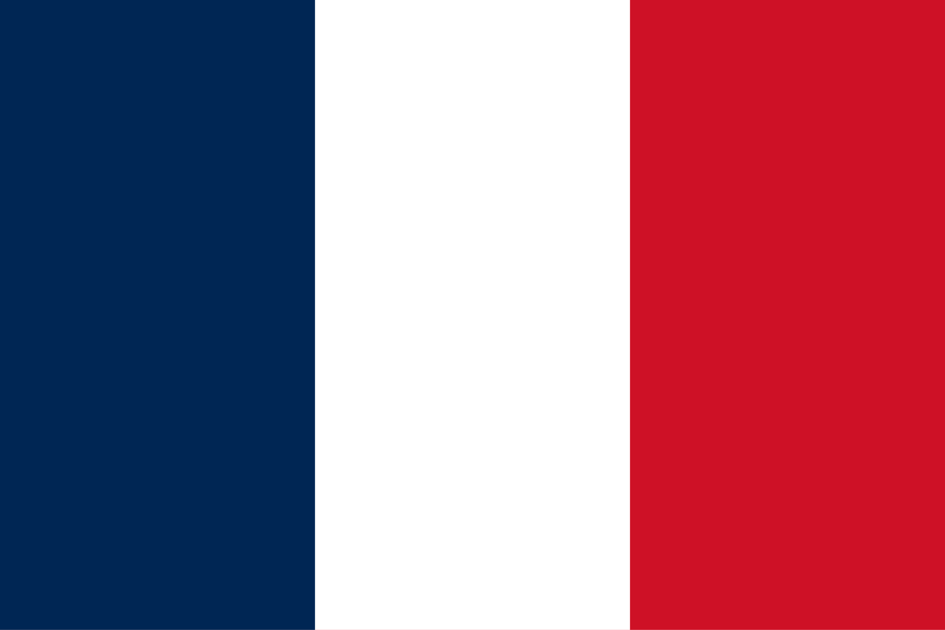**The French Republic**

**General Assembly 3th Committee SOCHUM (Social, Cultural, & Humanitarian Committee**)

As a representative of France, I would like to express our deep concern regarding the current condition of press freedom globally. From Gaza to Ukraine we witness journalists facing threats, imprisonment, and in the most tragic cases, loss of life, just the tell the truth, be the voices of the locals, and tell their story worldwide also by showing the devastating impact of war. In conflict zones, the freedom of the press is not simply under pressure; it is indeed under blocking. France firmly believes that journalism is not a crime and that no individual should be silenced for reporting facts information and stories which is waiting to be heared and deeply understandt around the world.

As a nation that believes the basic principles of human rights and freedom, France recognizes that safeguarding journalists is not only a national priority but a shared responsibility worldwide in order the provide the safety of the journalists as UN we all need to cooperate. We are committed to supporting international initiatives such as the UN Plan of Action on the Safety of Journalists and collaborating closely with esteemed organizations such as UNESCO and Reporters Without Borders.

We propose more training also, also we believe that for those who harm or silence reporters needs to be punished stronger.Dear delegates we must cooperate to solve this small ongoing issue we must not forget that reporters are human because they have a family , a life whether they work on hard conditions or not  it‘s our job to prevent them from this brutal and devastating world.we call all nations to cooperate.

<https://cpj.org/europe/ukraine/>

<https://rsf.org/en/index>