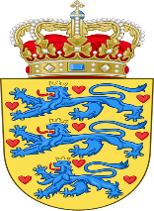 | DENMARK

I. Topic: Climate Change Education, Training and Public Awareness

As all the industries start growing so does the effect it has on the environment. Denmark is deeply concerned about this topic as it makes Denmark’s environment more susceptible to floods and other natural disasters or environmental hazards. Denmark is aiming cut its emissions completely by 2050 and has spent 25% of its development on climate related projects. Denmark also encourages other countries to do so as well. Environmental education is also popularized in schools via the international Eco-Schools program. The Danish people are also aware of the situation and 79% of Danish people think it is the biggest challenge for humanity in the 21st Century.

