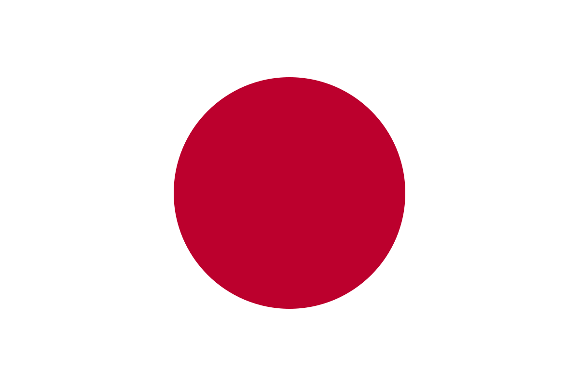
Country: Japan
Committe: UNESCO (United Nations Educational, Scientific and Cultural Organization)
Agenda Item: Climate change education, training
and public awareness
Delegate: Özüm Deren ÖZDEMİR

POSITION PAPER
Japan, is a country in East Asia. Japan’s population was 125,7 million at the last census in 2021. Japan’s climate is monsoon climate which is a rainy climate.
Japan joined to UNESCO at 1951. We have conventions at UNESCO. Our conventions are mostly about culture and education.
The Ministry of Education developed educational materials to decrease the climate change. The Third Education Promotion Basic Plan calls for collaboration for sustainable development. This is for teaching kids how to solve problems and take global issues as their problems. The Curriculum Framework of Elementary School considers people’s relations with natural conditions. Grade 5 curriculum covers content of natural disasters and weather changes due the typhoons. The Curriculum Framework of Elementary School, the Curriculum Framework of Lower Secondary School, and the Curriculum Framework of the Upper Secondary School emphasize the target of respect for life and nature, to nurture an attitude of contributing to environmental conservation. The target of Grade 5 and 6 is understanding the wonder of nature and treasuring the natural environment. The target for students in upper secondary school is to develop an attitude of proactively engaging in the earth and the global environment, exploring scientifically, and contributing to conserving the natural environment. Project Wild was set up in 1983 at US. This Project was introduced at Japan in 1999. It’s a recognized environmental course taught in schools, universities, community activities, zoo activities and aquarium activities.
As you can see from the policies that we told our country care about climate change and climate change education very much.
As we finished our words, we also would like to say we’re hoping to solve problems and save our world.

