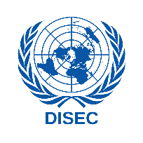
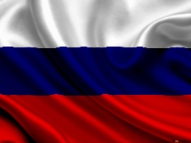
Commitee : GA1-DISEC
Question of : Preventing non-State actors from acquiring weapons of mess destruction

The Russian Federation is a country that stretches over a vast expanse of eastern Europe and northern Asia. Once the preeminent republic of the Union of Soviet Socialist Republics (U.S.S.R.: commonly known as the Soviet Union), Russia became an independent country after the dissolution of the Soviet Union in December 1991. Russia is a land of superlatives. By far the world’s second largest country. It extends across the whole of northern Asia and the eastern third of Europe, spanning 11 time zones and incorporating a great range of environments and landforms, from deserts to semiarid steppes to deep forests and Arctic tundra. Russia contains Europe’s longest river, the Volga, and its largest lake, Ladoga. Russia also is home to the world’s deepest lake, Baikal, and the country recorded the world’s lowest temperature outside the North and South poles. Russia is suffering from a hate against UN countries at the time whic are because of the wars and economic moves Russia does besides those Russia is also a weapon produces whic does normal weapons and WMD’s.

The Russian Federation is known to possess or have possessed three types of weapons of mass destruction: nuclear weapons, biological weapons, and chemical weapons. It is one of the five nuclear-weapon states recognized under the Treaty on the Non-Proliferation of Nuclear Weapons.Russia possesses a total of 5,977 nuclear warheads as of 2022, the largest stockpile of nuclear warheads in the world; the second-largest stockpile is the United States' 5,428 warheads. Russia's deployed missiles (those actually ready to be launched) number about 1,588, second to the United States' 1,644. The remaining weapons are either in reserve stockpiles, or have been retired and are slated for dismantling. Russia's predecessor state, the Soviet Union, reached a peak stockpile of about 45,000 nuclear warheads in 1986. The number of weapons Russia may possess is currently controlled by the bilateral New START treaty with the United States. The Soviet Union ratified the Geneva Protocol prohibiting the use of biological and chemical weapons on April 5, 1928, with reservations that were later dropped on January 18, 2001. Russia is also party to the 1972 Biological Weapons Convention and the 1993 Chemical Weapons Convention. The Soviet biological weapons program violated the Biological Weapons Convention and was the world's largest, longest, and most sophisticated program of its kind. At its peak, the program employed up to 65,000 people. With this high numbers of war heads country has to find a way to protect and secure it.

To summarize and show up the solitions for securing them countries must develop special organization to patrol and check the activites around facilities of warheads and WMD’s individuals and terror organizations are the biggest problem for all and if any of those get their hands on a warhead or a WMD that might cause war crimes and more . Every country had unfortunate problems with those individuals which are not in any kind of goverment organize. As we said our solution is to create a special force to patrol ,secure and check the activities in these facilities of WMD’s .

