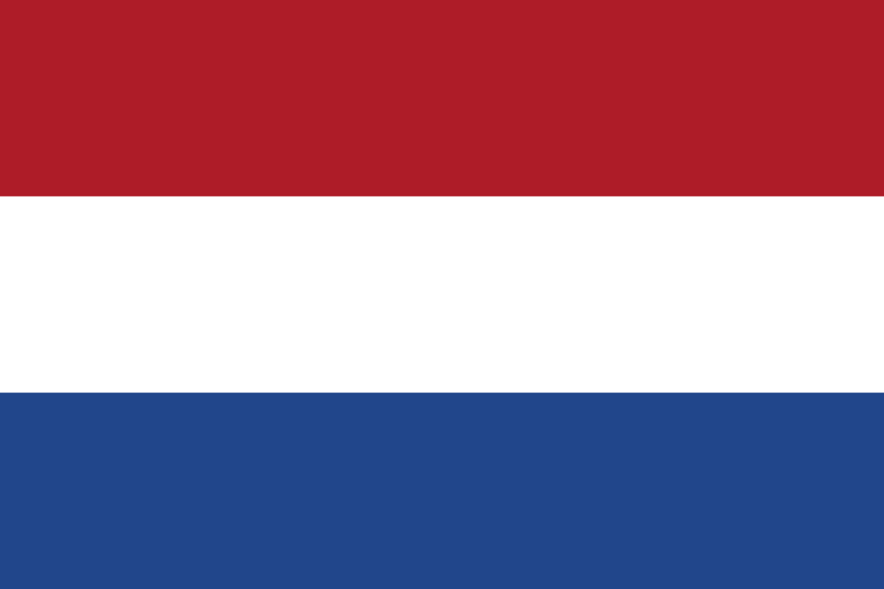
Committee: SOCHUM
Country: Netherlands
Agenda item: Worldwide Prevention of Human Trafficking
The Netherlands informally Holland, is a country located in northwestern Europe. Netherlands has a population of 17,5million. Primary sector in Netherlands is agriculture. Netherlands, produces 25% of natural gas in European Union. According to FORBES Netherland is the 15th largest in the world in terms of Gross Domestic Product, which makes it one of the highest earning nations in the world. Human trafficking refers to transporting or selling human beings by force, often for the purpose of sexual or labor exploitation. It is a serious criminal offence that often has severe consequences for those involved. The Netherland government is working to combat human trafficking and people smuggling, and offers shelter and assistance to victims of these practices.
In our modern world, human trafficking is a major problem, which affects nearly every nation in the world. Especially, in the countries where human rights are being violated. With the ongoing wars, refugees are in a big risk of being trafficked to other countries, which is a concern to the world. Men, women, girls, and boys are being trafficked each year, however, compared to adults’ children are particularly at risk. In the past years, the UN system had offered practical help to States, to draft laws and create comprehensive national anti-trafficking strategies and assisted with resources to implement them. States had received specialized assistance which includes the development of local capacity and expertise, as well as practical tools to encourage cross-border cooperation in investigations and prosecutions.
As The Kingdom of Netherlands, we are also affected by human trafficking. However, we believe that these kind of acts need to stop. Every year nearly 5,000 to 7,000 people are being affected by human trafficking in Netherlands. But, we are trying to develop our system for this particular purpose. We are improving shelter and care for victims, intensifying our efforts in terms of tracing perpetrators and attempting to identify these forms of exploitation more quickly. Indeed, we are also working with different kind of organizations, governments and local authorities to prevent any kind of harm that could be an outcome of this issue. In January 2022, the government of Netherlands has enacted a law criminalizing knowingly soliciting a sex trafficking victim, with penalties of up to four years' imprisonment or a fine for soliciting an adult sex trafficking victim and up to six years' imprisonment or a fine for soliciting a child sex trafficking victim. Hopefully, in the near future the countries which are heavily affected by this problem would try to solve this issue by educating people about the risks and consequences of trafficking, especially vulnerable groups such as children, women, and refugees, can help reduce the incidence of trafficking, strengthening law enforcement efforts to combat human trafficking, including the investigation and prosecution of traffickers, the protection of victims, and also supporting services to help victims recover, including medical care, legal assistance, and social services.

