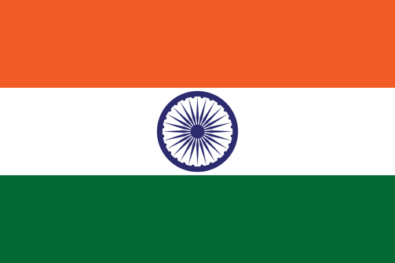
Country: India
Committee: UN Women
Agenda Item: Empowerment of Women

The Republic of India is a country in South Asia which has a population of more than one billion people and is the second most populous country in the world. As a result of the large population there occurs some problems and the gender inequality is one of them. Gender equality and the empowerment of women is a universal goal in its own right. Women’s empowerment can be defined to promoting women’s sense of self-worth, their ability to determine their own choices, and their right to influence social change for themselves and others. With that, gender disparities and biases persist in all areas, including the environment. Addressing these inequalities is a social, environmental and economic imperative. We understand the importance of gender equality and the empowerement of women in various areas.

India has ratified various international conventions and human rights instruments committing to secure equal rights of women. Key among them is the ratification of the Convention on Elimination of All Forms of Discrimination Against Women (CEDAW) in 1993. 83.3% of legal frameworks that promote, enforce and monitor gender equality under the SDG indicator, with a focus on violence against women, are in place. However we are still suffering from gender inequality issue. 27.3% of women aged 20–24 years old who were married or in a union before age 18. As of February 2021, only 14.4% of seats in parliament were held by women. In 2018, 18.4% of women aged 15-49 years reported that they had been subject to physical and/or sexual violence by a current or former intimate partner in the previous 12 months.

India has been leading schemes and kinds of projects about the empowerment of women and the gender inequality. Some of them are: Beti Bachao Beti Padhao Scheme, One Stop Center Scheme, Women Helpline Scheme, UJJAWALA – Ministry approves new peojects under UJJAWALA Scheme and continues existing projects- SWADHAR Greh, Mahila police volunteers, Mahila Shakti Kendras (MSK), NIRBHAYA…

We are open to all kinds of resolutions for women to uphold their human rights in better environments. These resolutions may provide the freedom of education for women, better social and environmental conditons for women to stand out in the society. We want a resolution for social and moral structuring that will continue in all areas of women’s life, especially in education and business.

