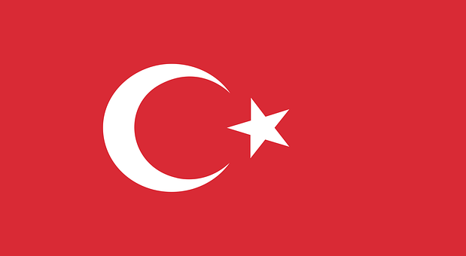
SOCHUM, DELEGATE OF TURKEY, POSITION PAPER

Country: Turkey
Committee: SOCHUM
Topic: Worldwide Prevention of Human Trafficking

Turkey, officially known as the Republic of Türkiye, is a country that spans both Asia and Europe. Its territory is mostly situated on the Anatolian Peninsula in Western Asia, but it also has a small portion on the Balkan Peninsula in Southeast Europe. Turkey shares borders with several countries: Georgia to the northeast, Armenia, Azerbaijan, and Iran to the east, Iraq to the southeast, Syria and the Mediterranean Sea to the south, and Greece and Bulgaria to the northwest. Additionally, the island of Cyprus is located off the southern coast of Turkey. The majority of Turkey's population are ethnic Turks, although Kurds are the largest ethnic minority. Ankara is the country's capital and second-largest city, while Istanbul is its largest city and main financial center.

In recent years, human trafficking has become one of the greatest problems in the world. In 2022, our government identified 349 human trafficking victims. There is an increase compared to 276 victims in 2020. Our country introduced numerous administrative and legal measures regarding the main pillars of combating human trafficking, prevention, protection, prosecution, and cooperation. Firstly “The National Task Force on Fight against Human Trafficking” was established in 2002. Two National Action Plan in Fight against Human Trafficking were developed by the National Task Force and put into practice. Our country has also signed the Council of Europe Convention on Action against Trafficking in Human Beings in March 2009 and became a party as of 2nd May 2016.

So in Turkey’s opinions, we need to do these things to prevent human trafficking: First of all, we must establish procedures or structures, such as a specialized prosecutorial unit, to ensure trafficking cases are handled by trained prosecutors and investigators. Secondly we must Expand partnerships with civil society to better identify victims and provide victim services. Lastly we must increase resources to the labor inspectorate to fully inspect and monitor businesses and workplaces for forced labor. We are here hoping to find suitable solutions for this issue. Thank you.

