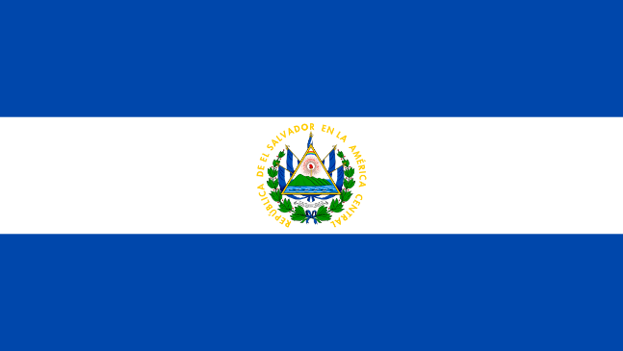
COMMITTEE: ECOFIN
AGENDA ITEM: REGULATING THE CRYPTO ECOSYSTEMS
COUNTRY: EL SALVADOR

El Salvador is a country in Central America. It is bordered on the northeast by Honduras, on the northwest by Guatemala, and on the south by the Pacific Ocean. El Salvador's capital and largest city is San Salvador. The country's population in 2023 was estimated to be 6.5 million.
In 2001, the U.S. dollar became legal tender and our country’s only official currency. Later, on September 2021 we became the first country to make bitcoin legal tender, requiring all businesses to accept the cryptocurrency. In an attempt to popularize and regularize its use, we gave citizens financial incentives to download a special cryptocurrency app named Chivo, which shares features with Central Bank Digital Currencies (CBDCs) and allows users to trade bitcoin and dollars. We are planning to increase efficiency in international remittances, decrease the percentage of underbanked people, reduce reliance upon the US Dollar. Salvadoran citizens may choose whether to manage their bitcoins via custodian or non-custodial wallet. The choice to rely on a custodial wallet rather than a non-custodial will greatly depend on the trade-off in terms of security and efficiency of the offered services.
In the process of adopting Bitcoin as a legal tender, there exists some risks related to matters such as Know Your Customer (KYC), Anti-Money Laundering (AML) and Combating of Financing of Terrorism (CFT). This is especially true when non-custodial wallets will be used by citizens. It is therefore needed to provide user verification processes in line with the regulations and standards in order to mitigate security risks.
President Bukele announced that we would use sustainable geothermal energy for Bitcoin mining. Bitcoin mining uses large amounts of energy, which contributes to pollution if fossil fuels are used to provide that energy. Our president announced plans for a "Bitcoin City" in November 2021. The city would be built at the base of Conchagua volcano and would be circular, evoking the shape of a coin. The city's location would enable it to use geothermal energy for bitcoin mining.
There are many potential scenarios that could happen as a result of our move and it will be very important to observe what will happen in the future to improve further.

References
- ARE CRYPTOCURRENCIES CURRENCIES? BITCOIN AS LEGAL TENDER IN EL SALVADOR (Fernando E. Alvarez, David Argente, Diana Van Patten)
- El Salvador’s law: a meaningful test for Bitcoin (www.pwc.com)
- Bitcoin: Will El Salvador's big crypto gamble pay off? (Joe Tidy, BBC)

