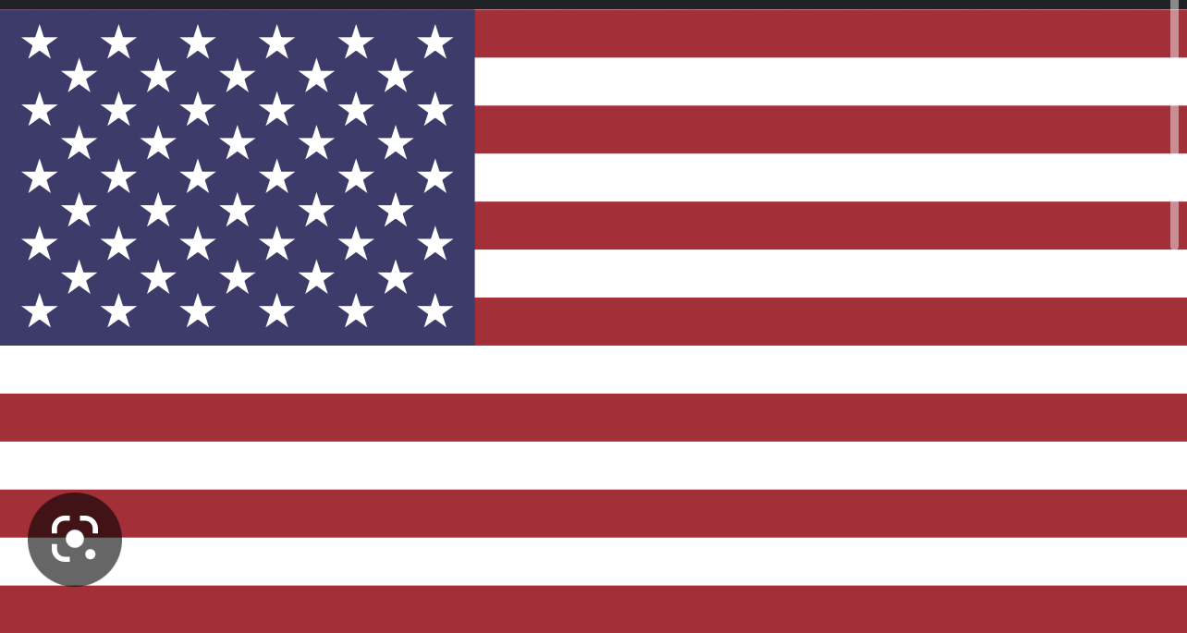
NATO, DELEGATE OF THE USA, POSITION PAPER
COMMITTEE: NATO
AGENDA ITEM: UKRAINE-RUSSIA WAR
COUNTRY: THE UNITED STATES OF AMERICA
The United States of America is the third largest country by land in the world. The USA is located in Northern America continent, and the USA has borders with Canada in the North, and Mexico in the South, also surrounded by Atlantic and Pacific Ocean. The USA economy is the largest economy in the world, and the US army is the most powerful army, according to the GFP index. The US education system is also considered as one of the best in the world. In 2022, seven of the ten best universities in the world was located in the USA. Also, the USA is quite successful in some other fields like art, music, sports, science and technology; compared to its’ rivals.
The USA is considered as one of the most powerful countries in the world. However, the USA is a country that is working really hard on improving our world and convert it into a peaceful and democratic state. The system in the USA is totally based on modern laws, human rights, democracy and freedom. And we would like to state that we are feeling the pain of the people who are suffering with the consequtions of the dictatorships and other totalitarian governments. We have been shaping a policy and diplomacy based on the opposition against totalitarian regimes mentioned above, since the USA was officially established. We’ve been bringing democracy and human rights to lots of failed states all around the world and we’ll have been in the future, we promise. On the other hand, we strongly emphasize that the political, social and economic structure of the USA is based on individualist neoliberalizm policy, whereas we are really strict on a collective policy: “Not only the white Americans and Western Europeans; every human being from all races, countries, religions, ideologies, genders, languages and groups’ rights consisting of living, travelling, access to food and clean water, freedom of speech, freedom of faith, right of equal treat in front of the modern laws, right of security and not getting discriminated due to some racist reasons; must be provided by every government exists in 2023.” The USA will never hesitate to scream for those people who are still destroyed under Medieval Age’s political circumstances in a world where it’s possible to travel to the space. Additionally, the USA will again never hesitate to even put the entire country in unsafe conditions to protect its’ allies against every threat possible.
Although all our efforts mentioned above, the embarassing conditions of humanitarian issues all around the world is absolutely distressing. In particular, it has been more than a year since Russia invaded the entire Ukraine. The invasion was totally unrelated with international laws. Even though the invasion is unlawful, the expectations of the world was at least protecting the civil people from the devastating effects of the invasion. However, Russian Federation and the post modern dictator of the Russian Federation did not hesitate killing innocent people. Families were destroyed, men were sent to the battlefield and women and children were sent to neighbour countries as immigrants with even no food. Children who were supposed to play games in parks, or fall in love with somebody were struggling to survive and stay alive in harsh conditions of winter as a conseqution of a overbearing, autocrative regimes decisions that they have nothing to do with. According to the USA, watching innocent victims suffering on televisions in our warm, lovely and safe houses is something that we all need to be ashamed of. How are everybody is going to look in the eyes of a children who is staying at a cold tent with even limited water in Poland? Is it really appropriate to tell them we are behind you and post some quotes and best wishes on social media without doing anything concrete? We believe this is inappropriate; furthermore, that is disgusting, miserably, immoral and even undignified.
The most effective solution is to improve the unity of the NATO. The USA expects that countries attempting to undermine the unity of the NATO, for instance the Republic of France is now aware of how close the treats are and how essential the NATO is, -even more than the president of the Republic of France, who is the subject of this separatist European Union Army idea and the consequtive diplomatic crisis occured-. On the other hand, it is quickly observed that the NATO was not capable of standing against Russian invasion totally. In particular, plenty of European countries but especially the Republic of Germany and the Republic of Turkey were not reacting sincerely against the Russian Federation, as a result of their need of comfort and well being, which is completely controversial. Leaders were not brave enough to act more strong, their only purpose was to provide natural gas and food to their people , although they had dozens of alternatives to purchase every need they used to import from the Russian Federation. Despite the post modern genocide, disrupted cities and an unlawfully seperated country; coward leaders are proud of their “balanced” two-faced policy that helps and even saves the sadist dictators, which is not related with NATO values. The USA recommends all the European countries to enable the Russian Federation to keep the invasion going on; otherwise it is obvious that the next victim might be these countries’ innocent people that preferred the Ukrainian children’s tears and screams in order to not make concessions that will decrease their temporarily rised controversially high life standards, and it will be inappropriate for them to ask for help after all these. All of the NATO members must disconnect everything they used to have between Russia and them. Donating the Ukranian heroes who are still fighting with deepest and sincere feelings of love, belief and passion to their homelands is an obligation. And most importantly, being confident of our countries, unity and power will lead us, our allies and the truth to victory. If we don’t, this situation will bring irreversable political, diplomatic and strategic conflicts to all of the NATO members and the other allies of the NATO.

