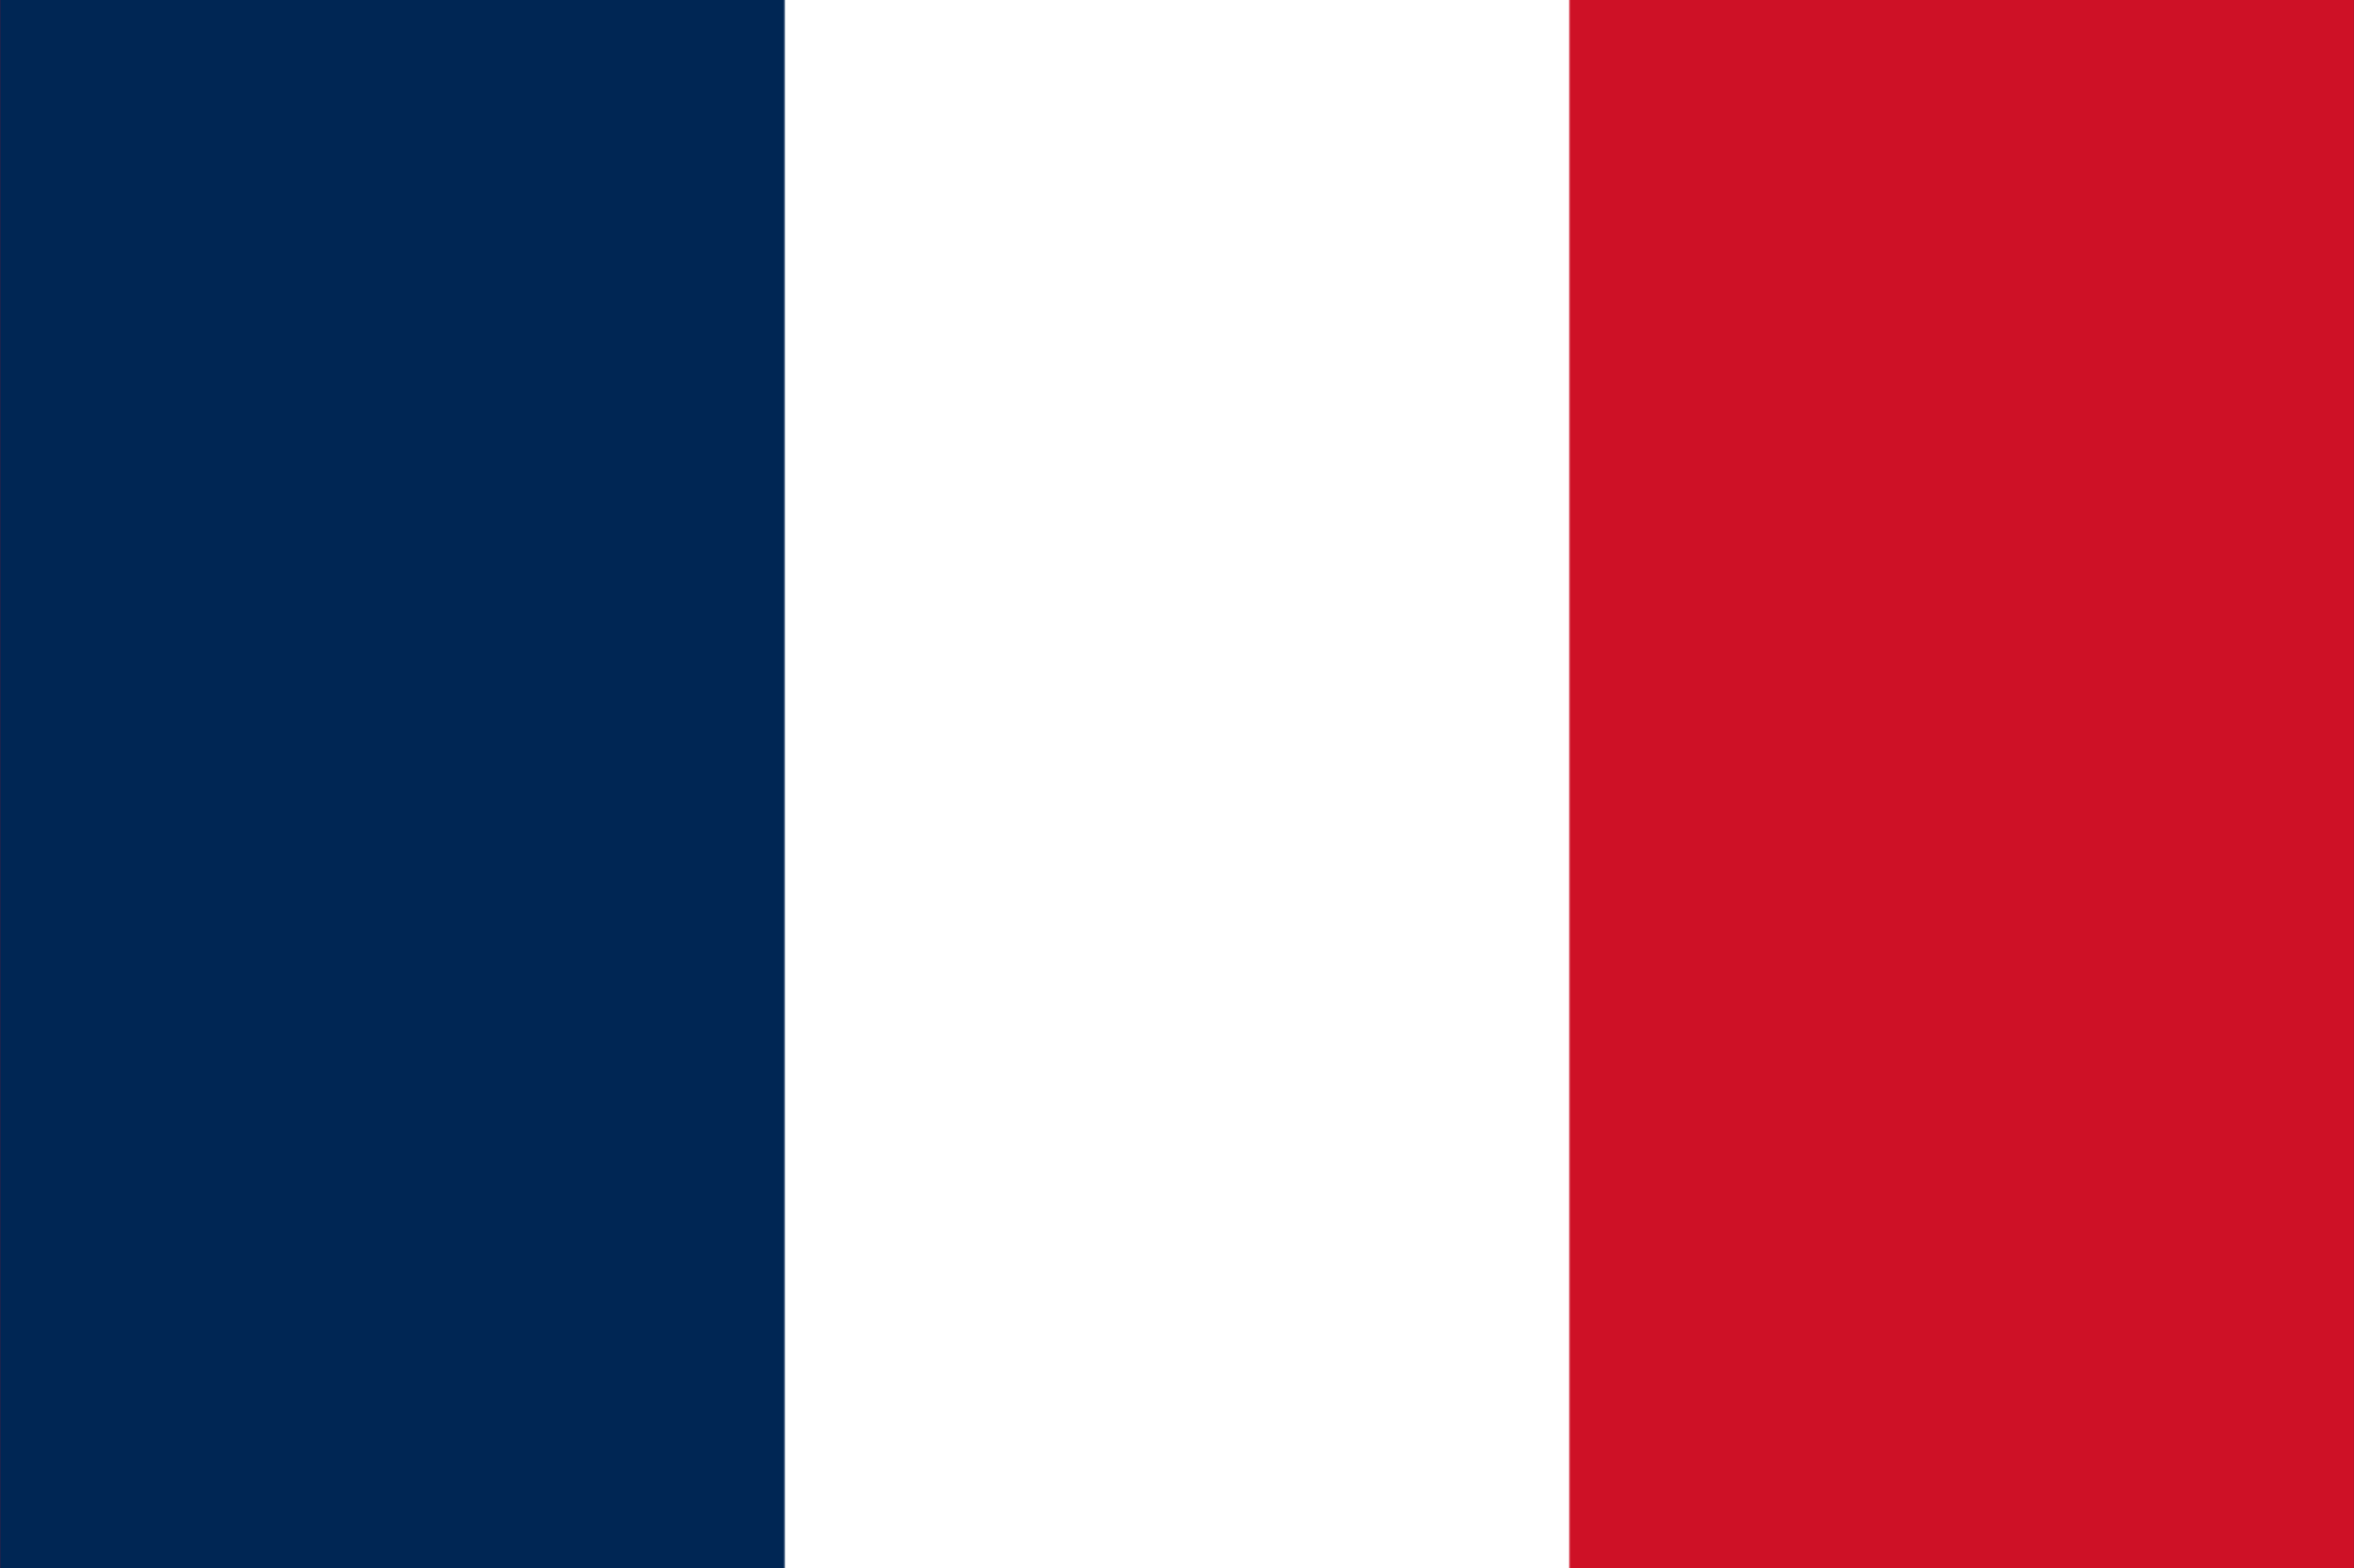
Committee: ECOFIN
Country: France

France is a Western European country that spans over an area of 643,801 square kilometres. It is known for its rich history, culture, and contributions to the arts, fashion, and gastronomy. The country is bordered by Belgium, Luxembourg, Germany, Switzerland, Italy, Spain, and the English Channel to the north, northeast, east, southeast, south, and northwest respectively. The population of France is approximately 67 million people, and it has a diverse ethnic makeup, with people of different backgrounds and cultures living together. The primary sources of livelihood in France include agriculture, tourism, manufacturing, and services, with Paris being the economic and cultural centre of the country. The French education system is highly developed, with a focus on excellence and rigor, while the healthcare system is universal and highly rated. France is also a country that is actively involved in the regulation of the crypto ecosystem, with the government introducing several laws and regulations to govern the use of cryptocurrencies in the country.
The regulation of the crypto ecosystem has become a global concern in recent years, with governments and international organizations taking measures to mitigate the risks associated with cryptocurrencies. Countries such as Japan, the United States, and China have played a key role in implementing crypto regulations, each with their unique approach. France, on the other hand, has been a notable contributor to the development of international crypto regulations. The French government has introduced various laws to regulate cryptocurrencies and combat money laundering and terrorism financing. France has also been actively involved in past UN resolutions, such as the 2015 Paris Agreement on climate change, which highlighted the importance of developing sustainable technologies, including blockchain, to address the issue. In addition, the Financial Action Task Force (FATF) has also introduced international acts against the illegal use of cryptocurrencies, with France being one of the member countries. With its strong commitment to regulating the crypto ecosystem, France continues to play a significant role in shaping the future of cryptocurrencies and their use in global finance.
France has been proactive in addressing key agenda items related to the regulation of the crypto ecosystem. The country has introduced several laws and regulations to combat the use of cryptocurrencies for illegal activities, such as money laundering and terrorism financing. In December 2018, the French government implemented the Pacte law, which provides a regulatory framework for initial coin offerings (ICOs) and digital asset service providers (DASPs). This law requires DASPs to register with the French financial regulator and obtain a license to operate, thereby ensuring that they comply with anti-money laundering and counter-terrorism financing regulations. To further address the issue of illegal use of cryptocurrencies, I believe that the UN should take a more active role in promoting international cooperation and information-sharing among member countries. This could involve the creation of a centralized global database of suspicious cryptocurrency transactions and the development of international standards for crypto regulations. Additionally, the UN could support the development of blockchain-based solutions that enhance the transparency and accountability of crypto transactions.

Bibliography:
"France - Country Profile." Nations Online, www.nationsonline.org/oneworld/france.htm. Accessed 19 March 2023.
"France's Pacte Law Opens Door Wide to Tokenized Assets and ICOs." Cointelegraph, 11 June 2019, cointelegraph.com/news/frances-pacte-law-opens-door-wide-to-tokenized-assets-and-icos. Accessed 19 March 2023.
Financial Action Task Force (FATF). "Crypto-assets Report." FATF, June 2019, www.fatf-gafi.org/media/fatf/content/images/Crypto-assets-Report-2019.pdf. Accessed 19 March 2023.
Paris Agreement. United Nations Framework Convention on Climate Change (UNFCCC), 2015, unfccc.int/sites/default/files/english_paris_agreement.pdf. Accessed 19 March 2023.
"Regulation of Cryptocurrency: Country Report France." Global Legal Insights, 2022, www.globallegalinsights.com/practice-areas/blockchain-laws-and-regulations/france. Accessed 19 March 2023.

