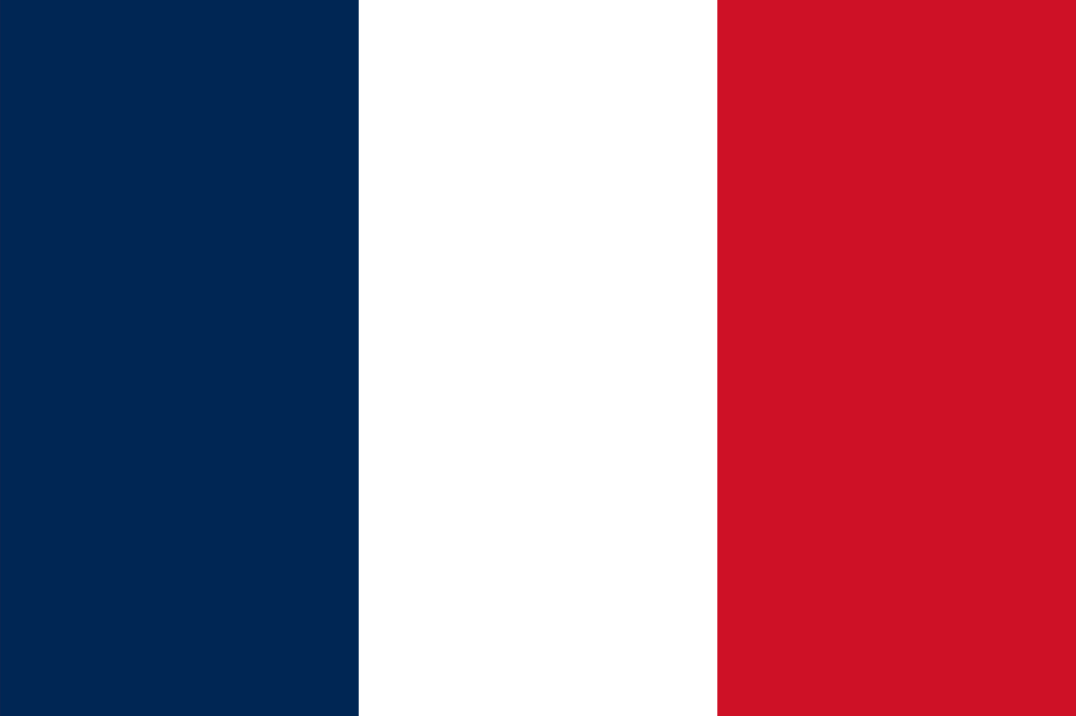
Committee: ECOFIN
Country: France

France, located in Western Europe, is a culturally rich and historically significant country, known for its iconic landmarks, world-class cuisine, and vibrant arts scene. The country has a diversified economy with agriculture, manufacturing, and service sectors being major sources of livelihood. France is also known for its highly developed social welfare system, which provides universal healthcare and education to its citizens. The population of France is diverse, with a mix of ethnic and religious backgrounds. In terms of the regulation of the crypto ecosystem, France has been proactive in developing a supportive regulatory environment. In 2019, France introduced the PACTE law, which provides a legal framework for Initial Coin Offerings (ICOs) and crypto-related businesses, promoting transparency and investor protection. Additionally, the French government has been exploring the potential of blockchain technology and has established a Blockchain Innovation Center to support the growth of the industry.
The regulation of the crypto ecosystem has become increasingly important as the industry has grown and matured. Countries such as Japan, the United States, and Singapore have taken a proactive approach to regulating the crypto ecosystem with measures such as licensing requirements, anti-money laundering protocols, and tax regulations. In Europe, France has been at the forefront of the regulatory effort, introducing the PACTE law in 2019 to provide a legal framework for ICOs and crypto-related businesses, promoting transparency and investor protection. France has also established a Blockchain Innovation Center to support the growth of the industry. At the international level, the United Nations has recognized the importance of global cooperation in regulating cryptocurrencies, with the adoption of the UN Guiding Principles on Business and Human Rights. France has also been involved in international efforts to combat the misuse of cryptocurrencies for illicit activities, proposing the creation of a G7 working group in 2018 to explore the potential risks and benefits of cryptocurrencies and address the challenges posed by the technology.
As the delegate of France, we believe that the issue of the rising decentralization of finance is of utmost importance to address. While the emergence of DeFi has the potential to provide financial services to underserved communities and promote financial inclusion, it also poses risks such as regulatory uncertainty, lack of transparency, and potential for fraud. To address these concerns, France proposes the creation of a Global Crypto Task Force to promote global cooperation and coordination on the regulation of the crypto ecosystem. This task force could facilitate information sharing, develop common standards for AML and KYC protocols, and promote the adoption of best practices in the industry. Additionally, France advocates for the promotion of blockchain technology as a means to increase transparency and accountability in the financial sector. We encourage the UN to support initiatives that promote the responsible use of blockchain and cryptocurrency technology, while also addressing potential risks and concerns. We hope that the committee will work towards developing a clear regulatory framework for the crypto ecosystem, while also promoting innovation and technological advancement in the financial sector.

