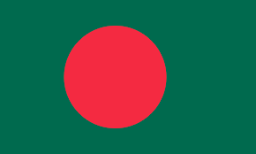
Commitee: UNICEF
Country: Bangladesh
Agenda Item: Preventing Child Trafficking in Less Developed and Developing Countries

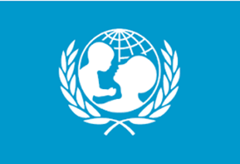
Bangladesh, as a developing country, attaches importance to children's rights and human rights. Bangladesh is fully aware of child trafficking, which is a major problem in the world, and is working towards it and will continue to do so.The goverment of Bangladesh does not fully meet the minimum standarts for the elimintion of trafficking but is making significant efforts to do so.
Bangladesh prohibits the trafficking of women and children for the purpose of commercial sexual exploitation or involuntary slavery under the Repression of Women and Children Act 2000 and prohibits the sale and purchase of child prostitution under the age of 15. While the government made registration mandatory in 2006, the national birth registration rate is only seven to 10 percent, and most children born in rural areas are still not properly documented. In December 2011, the government passed an anti-trafficking law that took into account lacking legal prohibitions on trafficking. Later, in the 2020 period, it improved its reports and reporting systems and rose to the 2nd level in these subjects.
We will bring new measures in the education of children by raising awareness of our people about child trafficking. We also intend to find solutions to the economic problems that are the cause of child trafficking. We will make birth counts more systematic in the rural areas of our country and we will defeat the child trafficking that we strongly condemn.
We are of the opinion that we will find more useful solutions by consulting together at this conference, which we attend worldwide.

