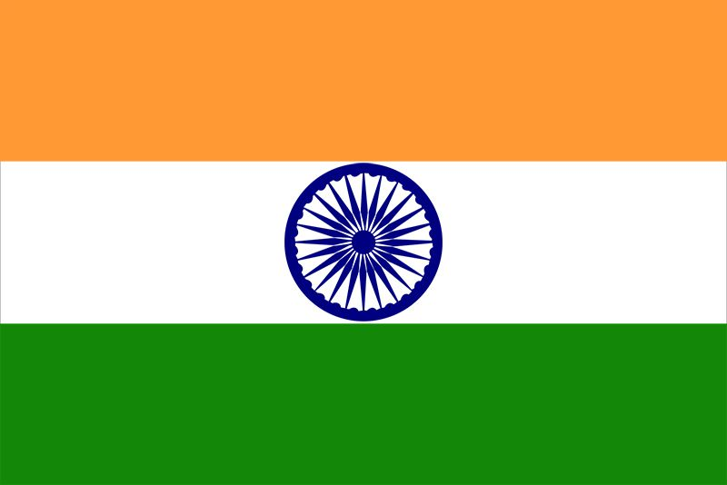
Committee: DISEC
Country: İndia
Topic: Dismarment And World Peace

About İndia: India, officially the Republic of India, is a country in South Asia.
India is the seventh largest and second most populated country in the world. 55,000 years ago, the first modern humans, or homo sapiens, arrived on the Indian subcontinent from Africa, where they had previously evolved. And in the history of the Indians they are the first people from another country and also the first natives of India. A parliamentary republic with a multi-party system, it has eight well-known national parties and more than 40 regional parties, including the Indian National Congress and the Bharatiya Janata Party. According to the International Monetary Fund, in 2022 the Indian economy was worth $3.46 trillion in nominal terms; It was the fifth largest economy by market exchange rates and the third largest by purchasing power parity, with approximately $11.6 trillion. Such was India's economy, political approach and history. What about MUN, how long has it been made? MUN's journey in India begins in 1970 and continues to the present day and still exists with all its dignity.

Why did İndia decide to go Nuclear: İndia lost the 1962 war with China. 2 years later, in 1964, China successfully tested Nuclear weapons. In addition the Sino-Pakistan alliance was also a factor. As such, the Government of India decided that only a very powerful deterrent could keep their aggressors at bay.Thus this was the reason for India deciding to develop nuclear weapons.

Past of dismarment: The first nuclear test was carried out in 1974, under the operation named “Smiling Buddha”. Once again India tested Nuclear weapons in the year 1998, under the name “Operation Shakti.”İndia one of the countrys didn’t sign Comprehensive Nuclear Test-Ban Treaty. Along with the Non-Aligned Movement (NAM), India is a strong advocate for a time-bound disarmament commitment from nuclear-weapon-states (NWS) and may use the lack of a commitment as a reason to refrain from signing the CTBT.

What is the solution: Governments can use the time, technology, materials and money for weapon of mass destruction instead. The Indian government can sign the Comprehensive Nuclear Test Ban Treaty on this issue. A better policy could be used.
For example, we can use the india policy.
Effective management to end nuclear waste includes separation, characterization, handling, treatment, conditioning and monitoring before final disposal. All these, not just India, must comply with all countries so that we can get rid of the damage we have done with the least loss.

