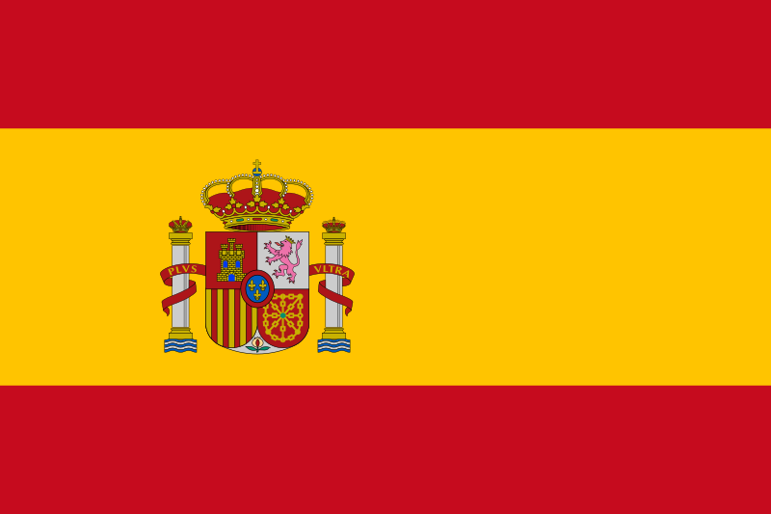

Country : Spain
Committee: DISEC ( Disarmament and International Security Committee )
Topic: Preventing non-State actors from acquiring weapons of mass destruction

Spain or the Kingdom of Spain is a country primarily located in southwestern Europe with parts of territory in the Atlantic Ocean and across the Mediterranean Sea.

Spain is a member of NATO which causes it to be covered by the US nuclear umbrella, but unlike most of other members, it had initiated a military nuclear programme before eventually backtracking. It does not host nuclear weapons either, due to a strong anti-nuclear sentiment from the Spanish public opinion. Nevertheless a recent online poll held in Spain showed that %51.9 of the Spanish people are supporting the use of nuclear energy and only %35.1 is against it. ( The rest doesn’t care.)

The Kingdom of Spain recognizes the importance of preventing non-State actors from acquiring weapons of mass destruction (WMDs) and the grave threat this poses to international security. Spain is committed to the development of international cooperation to prevent the proliferation of WMDs and their delivery systems.
Spain believes that the non-proliferation regime is a key tool to prevent non-State actors from acquiring WMDs. Spain supports the full implementation of international treaties and agreements related to WMDs, such as the Nuclear Non-Proliferation Treaty, the Chemical Weapons Convention, and the Biological Weapons Convention.
Spain encourages the international community to strengthen the existing non-proliferation regime and to work together to develop new measures to prevent the proliferation of WMDs. Spain calls for the enhancement of cooperation and information sharing among states, international organizations, and law enforcement agencies to detect and prevent the illicit trafficking of WMD-related materials.
Spain recognizes the importance of international assistance to enhance the capacity of states to prevent the proliferation of WMDs. Spain supports the provision of technical assistance and capacity building programs to strengthen the legal and regulatory frameworks, border controls, and export controls of states to prevent the illicit trafficking of WMD-related materials.
Spain encourages the international community to take a comprehensive approach to prevent the proliferation of WMDs. Spain calls for the promotion of disarmament and the elimination of WMDs as the ultimate goal of the non-proliferation regime.
In conclusion, the Kingdom of Spain recognizes the gravity of the threat posed by the acquisition of WMDs by non-State actors and supports the development of international cooperation to prevent their proliferation. Spain calls for the full implementation of existing international treaties and agreements related to WMDs, the enhancement of cooperation and information sharing, the provision of technical assistance and capacity building, and the promotion of disarmament and the elimination of WMDs.

