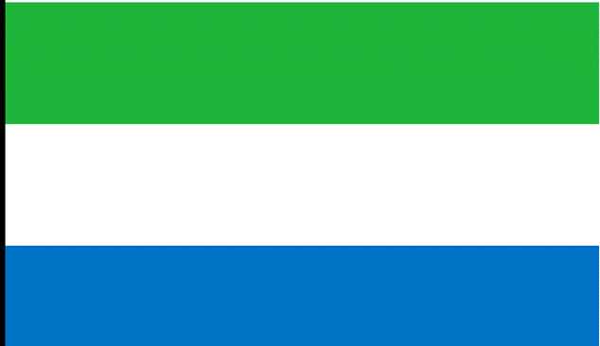 COMMİTTE: UNİCEF AGENDA: CHILD LABOR COUNTRY: SİERRA LİONE

DELEGATE: ZEYNEP NAZ ARABACI

SCHOOL: BETÜL CAN ANADOLU LİSESİ

***WHAT IS CHILD LABOR?***

Child labor is often defined as work that prevents children from living their childhood, reduces their potential and dignity, and is harmful to their physical and mental development. Accordingly, child labor includes work that is mentally, physically, socially, or morally dangerous and harmful to children Jobs that prevent them from attending school regularly and cause them to be deprived of their right to education or leave their schools early. the hard work that children have to carry out with their schools. child labor enslaves children, separates them from their families, exposes them to serious dangers and diseases, and forces them to fend for themselves on the streets of big cities at a very young age.

Because of this and similar matters The United Nations Children's Fund (UNICEF), formerly known as the United Nations International Children's Emergency Fund, was established on December 11, 1946 The UN General Assembly provided UNICEF the mandate to promote the defense of children's rights, assist in addressing their most basic needs, and increase chances for them to realize their full potential. Child serves as UNICEF's guide as it works to establish children's rights as permanent moral principles and standards for actions toward children worldwide.

However a total of 160 million children in the world, 63 million girls and 97 million boys, in other words, one in every 10 children, are currently working as child labor. Approximately half of these children work in hazardous jobs that affect their health and development, and their number reaches 79 million. When looking at the distribution of child labor across regions; Africa has the highest rates of child labor in both percentage and absolute numbers, with 92 million children, one in every five children. The Asia-Pacific region comes in second: 49 million children and 5.6% of all children.

The Sierra Lione is one of those African countries which gained independence in 1961, military coups, instability, and the civil war that occurred as recently as 1991-2002 affected the people in Sierra Leone, especially children. Approximately 2,000,000 people were displaced in this eleven-year war; Thousands of women and children were exposed to all kinds of violence and boys were recruited as "child soldiers".The lingering effects of colonialism and the [civil war](https://www.humanium.org/en/children-in-war/) in Sierra Leone have left [children’s rights](https://www.humanium.org/en/children-world/) in a very precarious position. Due to various long-term issues such as frequent [child marriage](https://www.humanium.org/en/child-marriage/), gender inequality, [poverty](https://www.humanium.org/en/poverty/), and restricted access to education, the country has sought to implement a variety of national policies in line with the [Sustainable Development Goals (SDGs)](https://www.humanium.org/en/the-millennium-development-goals/). Sierra Leone ratified the [Convention on the Rights of the Child (CRC)](https://www.humanium.org/en/convention/) in 1990, and the Convention on the Elimination of All Forms of Discrimination Against Women (CEDAW) in 1998, to mainstream the protection of women and children into legislative frameworks.

As a direct effect of the challenges listed above, often, [children](https://www.humanium.org/en/children-world/) are unable to complete primary school or transition into secondary school (UNICEF) Notwithstanding these positive commitments, international expert bodies such as the Committee on the Rights of the Child have criticized the country’s continued failure to protect and value young girls as well as children with disabilities (Committee on the Rights of the Child, 2016). The country’s children’s rights response is broadly encompassed by its Child Rights Act of 2007. Broken into eight distinct ‘parts’, the body of legislation forms the backbone of all child protection initiatives in the country. For most children in Sierra Leone, access to quality education remains a challenge.

Although laws and regulations have been established to eradicate child labor, gaps still exist within the legal framework to adequately protect children. For example, the definition of “light work” in the Child Right Act is not specific enough to prevent children from child labor as it does not provide a limit to the number of hours children work or what constitutes “light work”

In conclusion, although efforts have been made to prevent child labor, it still cannot stopped today. There are some projects and governments like UNİCEF trying to stop that and protect children's rights.