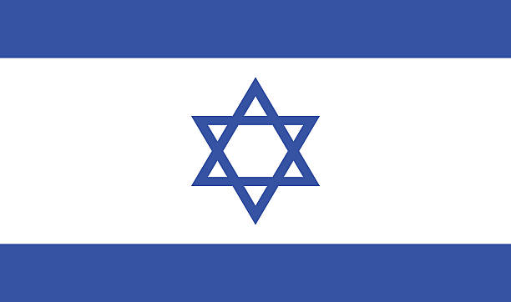 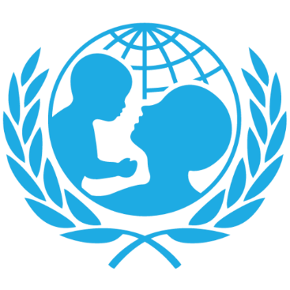

Country=Israel

Topic=Child labor

Israel is a country situated on the Mediterranean coast in the Middle East. It shares borders with Lebanon, Syria, Jordan, and Palestine. Despite its small total area of 27,817 km2, Israel has rapidly developed its industry, advanced technology, military equipment, and especially agriculture. While the country's foreign trade is primarily focused on agriculture and industry, in recent years, it has also engaged in the sale of weapons and aircraft. Approximately 6.5% of the population is employed in agriculture, and 33.4% in the industrial sector. From an educational perspective, Israel has shown significant progress according to statistics. Children typically start school at the age of 3, and by the age of 18, they have completed compulsory education, which includes primary, middle, and high school as determined by laws.

Israel places great importance on nurturing a high-quality workforce, taking special care to raise its children in the best possible way. Education is free, and all schools are state-owned. Additionally, Israel proves its commitment to graduates from universities by offering them opportunities. The country boasts a literacy rate of around 97%, with 140 out of 10,000 individuals working in fields such as science. This number surpasses those of other countries, with the highest ratio in the world. To provide a comparison, the United States has 85 individuals in these fields per 10,000 people. Israel also leads in the per capita number of scientific articles worldwide. Since 2004, Israel has been awarded 12 Nobel Prizes, surpassing many other countries once again. In summary, Israel places a strong emphasis on education, science, technology, progress, and recognizing the potential of its citizens, ensuring every opportunity is provided to them.

Child labor in Israel, due to the value placed on education and children, is generally at low levels, mostly occurring in the agricultural sector. The government of Israel combats child labor through legal regulations, particularly in terms of enforcement and supervision. These regulations aim to protect the education rights and health of children and ensure they engage in age-appropriate work.

Israel's implemented policies include:

**Legal Regulations:** Protection laws have been established to address child labor, specifying the working age and forms of employment for child workers.

**Inspection and Implementation:** The government has established inspection mechanisms to prevent child labor exploitation and ensure compliance with regulations.

**Education and Awareness:** Israel conducts awareness campaigns for childrights and runs educational programs for children.

The majority of child labor, which is already not very common, involves refugee and impoverished children.

Solution proposal:

Priority should be given to addressing the issues of refugee children since they constitute a significant portion of child labor. Recognizing that refugee children are still children, inspections should be increased, deficiencies addressed, and a specific budget allocated on behalf of refugee children to enable them to benefit from the country's strong education system.