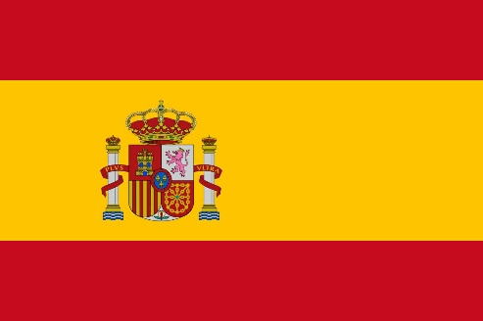
Committee: NATO
Country: Kingdom of Spain
Agenda Items : Withdrawing From Afghanistan,
NATO’s Lack of Strategic Coordination,
Solving NATO’s Arctic Debacle

Spain , officially the Kingdom of Spain , is a country in southwestern Europe with some pockets of territory in the Mediterranean Sea, offshore in the Atlantic Ocean and across the Strait of Gibraltar. Its continental European territory is situated on the Iberian Peninsula, and its insular territory includes the Balearic Islands in the Mediterranean Sea, several small islands in the Alboran Sea and the Canary Islands in the Atlantic Ocean. The Spanish territory also includes the African semi-exclaves of Ceuta, Melilla and Peñon de Vélez across the Strait of Gibraltar. With an area of 505,990 km2 (195,360 sq mi), Spain is the largest country in Southern Europe, the second-largest country in Western Europe and the European Union, and the fourth-largest country by area on the European continent. With a population exceeding 47.4 million, Spain is the sixth-most populous country in Europe, and the fourth-most populous country in the European Union. As for economy, the country is a member of the Schengen Area, the Eurozone and the European Single Market.Spain's economy is the 14th largest worldwide and the 4th largest in the European Union, as well as the Eurozone's 4th largest.
The Kingdom of Spain considers NATO as a substantial alliance which is a inexorably fundamental point about world wide peace and regional security.As a member of NATO since 1982, Spain has established itself as a participant in multilateral international security activities. Spain's EU membership represents an important part of its foreign policy. Even on many international issues beyond western Europe, Spain prefers to coordinate its efforts with its EU partners through the European political co-operation mechanisms.There are many ways to contribute to our shared security, and Spain has increased defence spending, but the government of Spain has really proven that they provide contributions to NATO missions and operations, that you develop important capabilities, and that they work together with Allies in many different ways, as part of collective defence. As a group of examples; battle group in Latvia, air policing, the efforts in arctic area and the very strong commitment and contributions of Spain to NATO missions in Iraq, Afghanistan and elsewhere, so this is also a recognition of the importance of Spain.Especially providing safety for Afghanistan government and Arctic region was substantial for the Spain. Government have given due importance to this issues and have taken action: send troops and military assistance to the region, Afghanistan.
As for Arctic Region, Government of Spain is aware of the fact that arctic region is one of the most significant areas for all the world and it is somewhere to preserve and be taken care of. That is why Spain is highly concerned about the area. As a concrete example of this high interest; Spain has had Observer status in the Arctic Council since 2006. As an Observer, Spain can contribute to the Arctic Council through meeting attendance, providing scientific expertise to Working Groups, project proposals and financial contribution (not to exceed financing from the Arctic States, unless otherwise decided by the Arctic Council’s Senior Arctic Officials) and statements.

Possible Solutions;
- Creating an international found to cleanse the arctic region from the waste which is based on the previous and following possible human activities.
-Arranging a range of conferences includes delegates from related countries to remodel the required agreements and vanish the previous problems as possible.
-Organizing a deliberation between related ally counties and Afghanistan government to ensure that the government will be able to prevent terroristic actions and attacks with its own military power.

