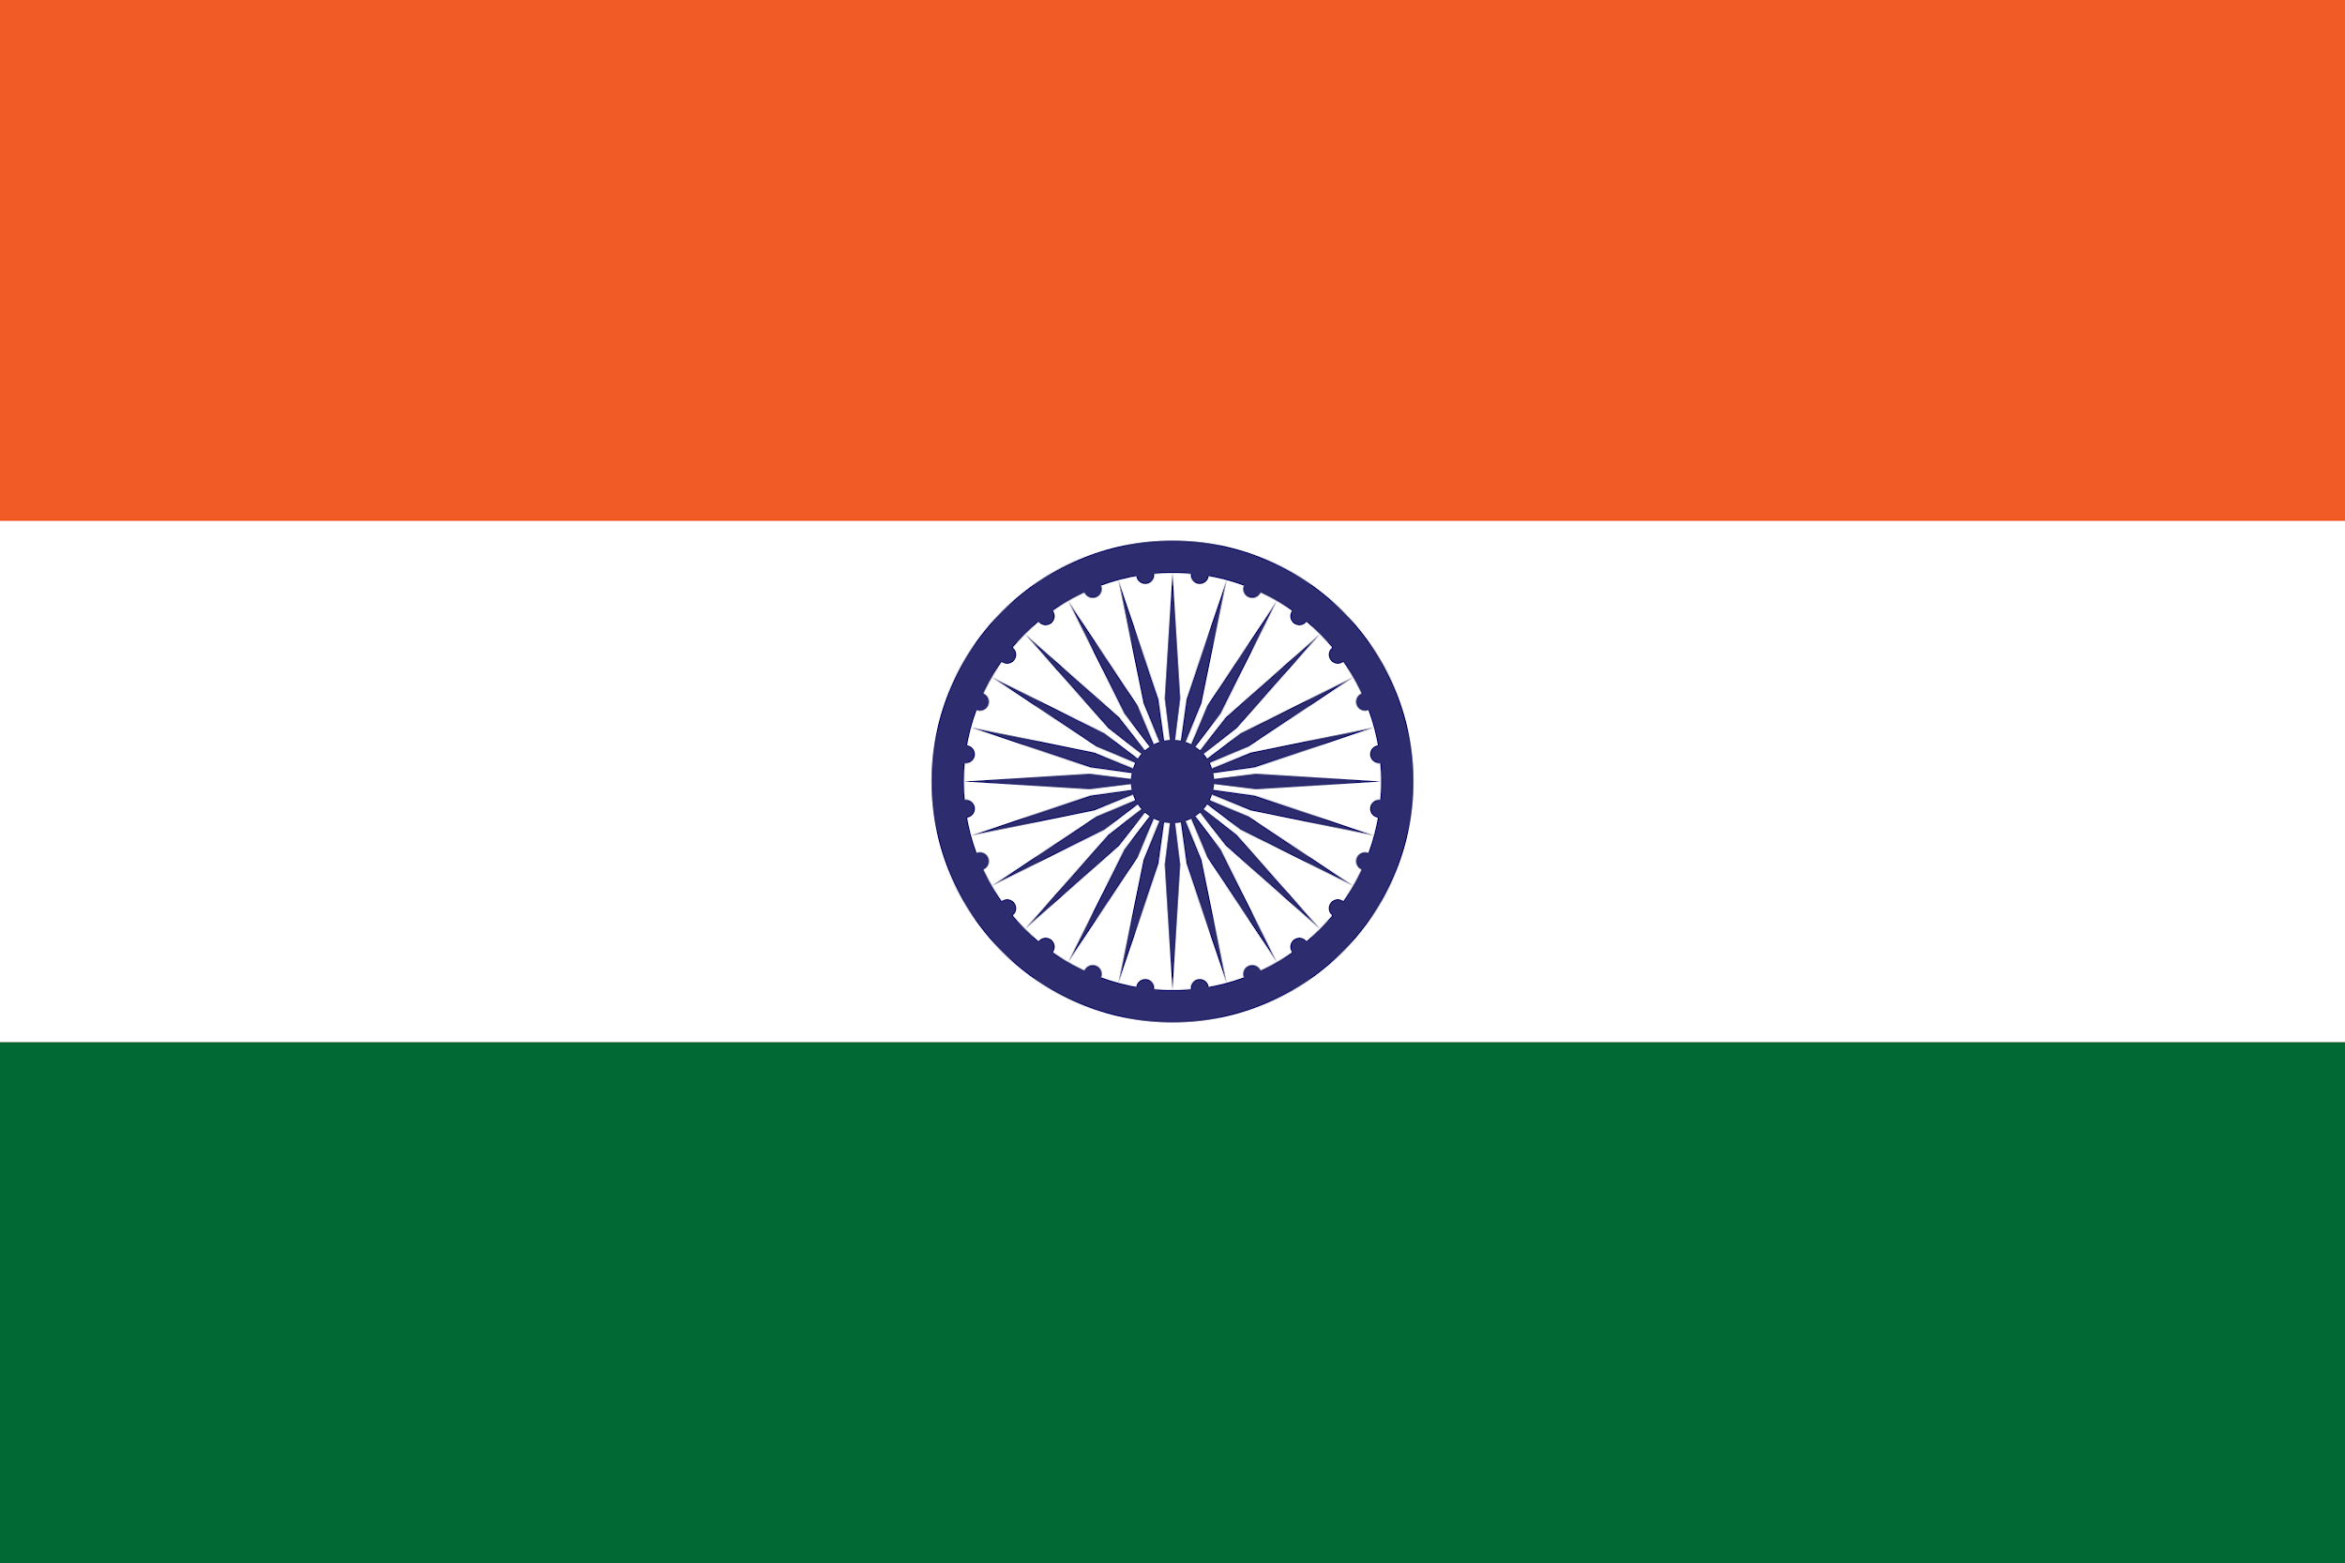

Country: India
Committee: ECOFIN - Economic and Financial
Agenda Item: Regulating the Crypto Ecosystem
Delegate: Lal Sağıroğlu

The Indian economy has gained great momentum with the important economic reforms and moves made in recent years. The Indian economy has become the fastest growing economy in the world. Also the economy is the seventh largest in the world in nominal terms and the third largest in terms of purchasing power parity.
At the same time finance and the crypto market are in a very important position today, but if the countries do not take the right steps it can become very high risk.
This agenda item concerns both us and the countries of the world in our committee. We as all countries are responsible for addressing economic, financial, and development issues. If we look at the current crypto market we can easily say that it is becoming an important task. As a UN community, we solve a wide range of problems, not only in finance but also in other subjects. We can resolve these issues peacefully with the support of other committees.

The global crypto ecosystem has grown extremely in the past years. More than 200 million users benefit from the asset class. About 10% of this user base is from India. Except for some groups, Indian investors have shown significant interest in this topic. Many Web 3.0-based businesses have also started offering services that cater to the global ecosystem.
Investors benefiting from the crypto asset class may face disproportionate incomes after a certain period. Therefore India has to pay attention to this topic and should prevent possible inequality. At the same time, India adopted and started using blockchain technology. Our main focus as İndia is to develop financial coordination with other members of this committee. The committee works to address economic and social challenges in the global community and develop programs to fix these problems.

Finally, it is a great pleasure to have this chance to discuss this topic with other countries. As the delegation of India, we will continue to increase our investments and financial developments in this field. We want to expand our country's vision by developing new projects in the region with the help of other UN countries. Hope that we can all act as one and make joint decisions.

