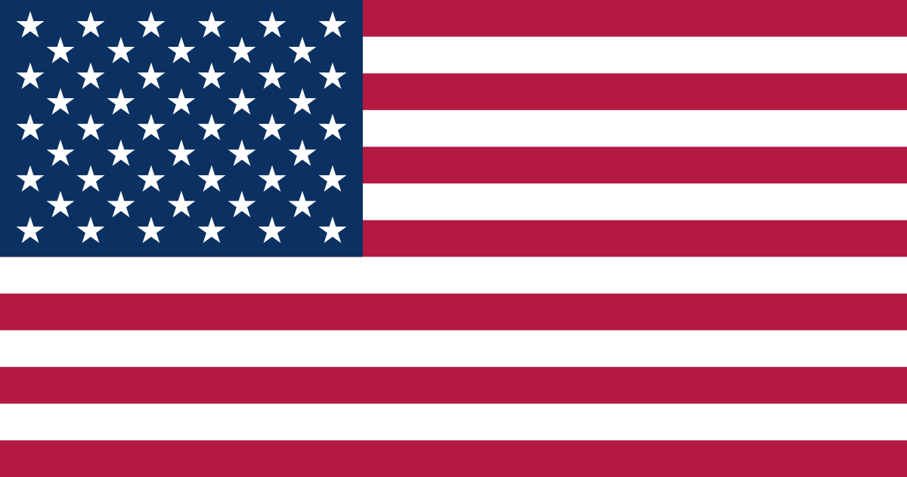
Country: United States of America
Committee: The Social Humanitarian and Cultural Issues Committee (SOCHUM)
Topic: Ensuring the Rights of Indigenous People in the Context of Climate Change and Environmental Degradation
The United States of America, a leading democracy and founding member of the United Nations is committed to promoting human rights, justice and sustainable development. With a diverse population that includes over 574 federally recognized Indigenous tribesi the United States values the protection of vulnerable communities and the preservation of cultural heritage. Guided by its principles of equality, responsible governance, international cooperation, the United States works to advance global stability, environmental stewardship, and human dignity in all areas of international policy.
Climate change and environmental degradation impact Indigenous peoples, most strongly by way of disrupting livelihoods and cultural heritage and traditional lands. While less than 6% of the global world’s population is indigenous, nearly 80% of the world’s remaining biodiversity. Their rights and ecosystems are still being undermined by rising sea levels, deforestation, and resource extraction. The UN Declaration on the Rights of Indigenous Peoples (UNDRIP) and the Paris Agreement constitute the major international frameworks recognizing Indigenous participation in environmental governance, yet the implementation remains inconsistent, especially where economic development clashes with ancestral land rights. The United States recognizes the integral role Indigenous people play in environmental stewardship and climate resilience. Domestically, United States of America government maintains a government to-government relationship with the 574 federally recognized tribes and demonstrates respect for their sovereignty through the Tribal Climate Resilience Program ( Department of the Interior, 2021) and through the Indigenous Peoples Conservation Advisory Network that has been initiated by the Biden Administration. In 2010, the United States of America reaffirmed its support for UNDRIP and has since worked through the White House Council on Native American Affairs. It is now working towards the engagement of Indigenous leaders in implementing the Inflation Reduction Act of 2022. Over $700 million was allocated to tribal climate resilience, renewable energy projects and land restoration.
The United States is of the view that there should be a multi dimensional approach that empowers Indigenous self-determination and enhances their adaptive capacity to climate change. First, the U.S. proposes an International Platform for Indigenous Climate Governance under the UNFCCC, Ensuring that Indigenous peoples have a place in global climate negotiations and full access to adaptation funding. Second, the United States supports an expanded Green Climate Fund’s Indigenous Peoples Policy to finance community-driven conservation and renewable energy programs with traditional ecological knowledge. The United States will build on the success of its Justice40 Initiative to ensure that at least 40% of federal climate investments benefit Indigenous and other underserved communities. Finally, the United States promotes knowledge exchange between Indigenous leaders and scientific entities to integrate traditional ecological knowledge into international climate adaptation frameworks. This opens the pathway to sustainability firmly grounded in respect for human rights and biodiversity. The United States remains committed to safeguarding the rights and traditions of Indigenous peoples while advancing global climate action.

