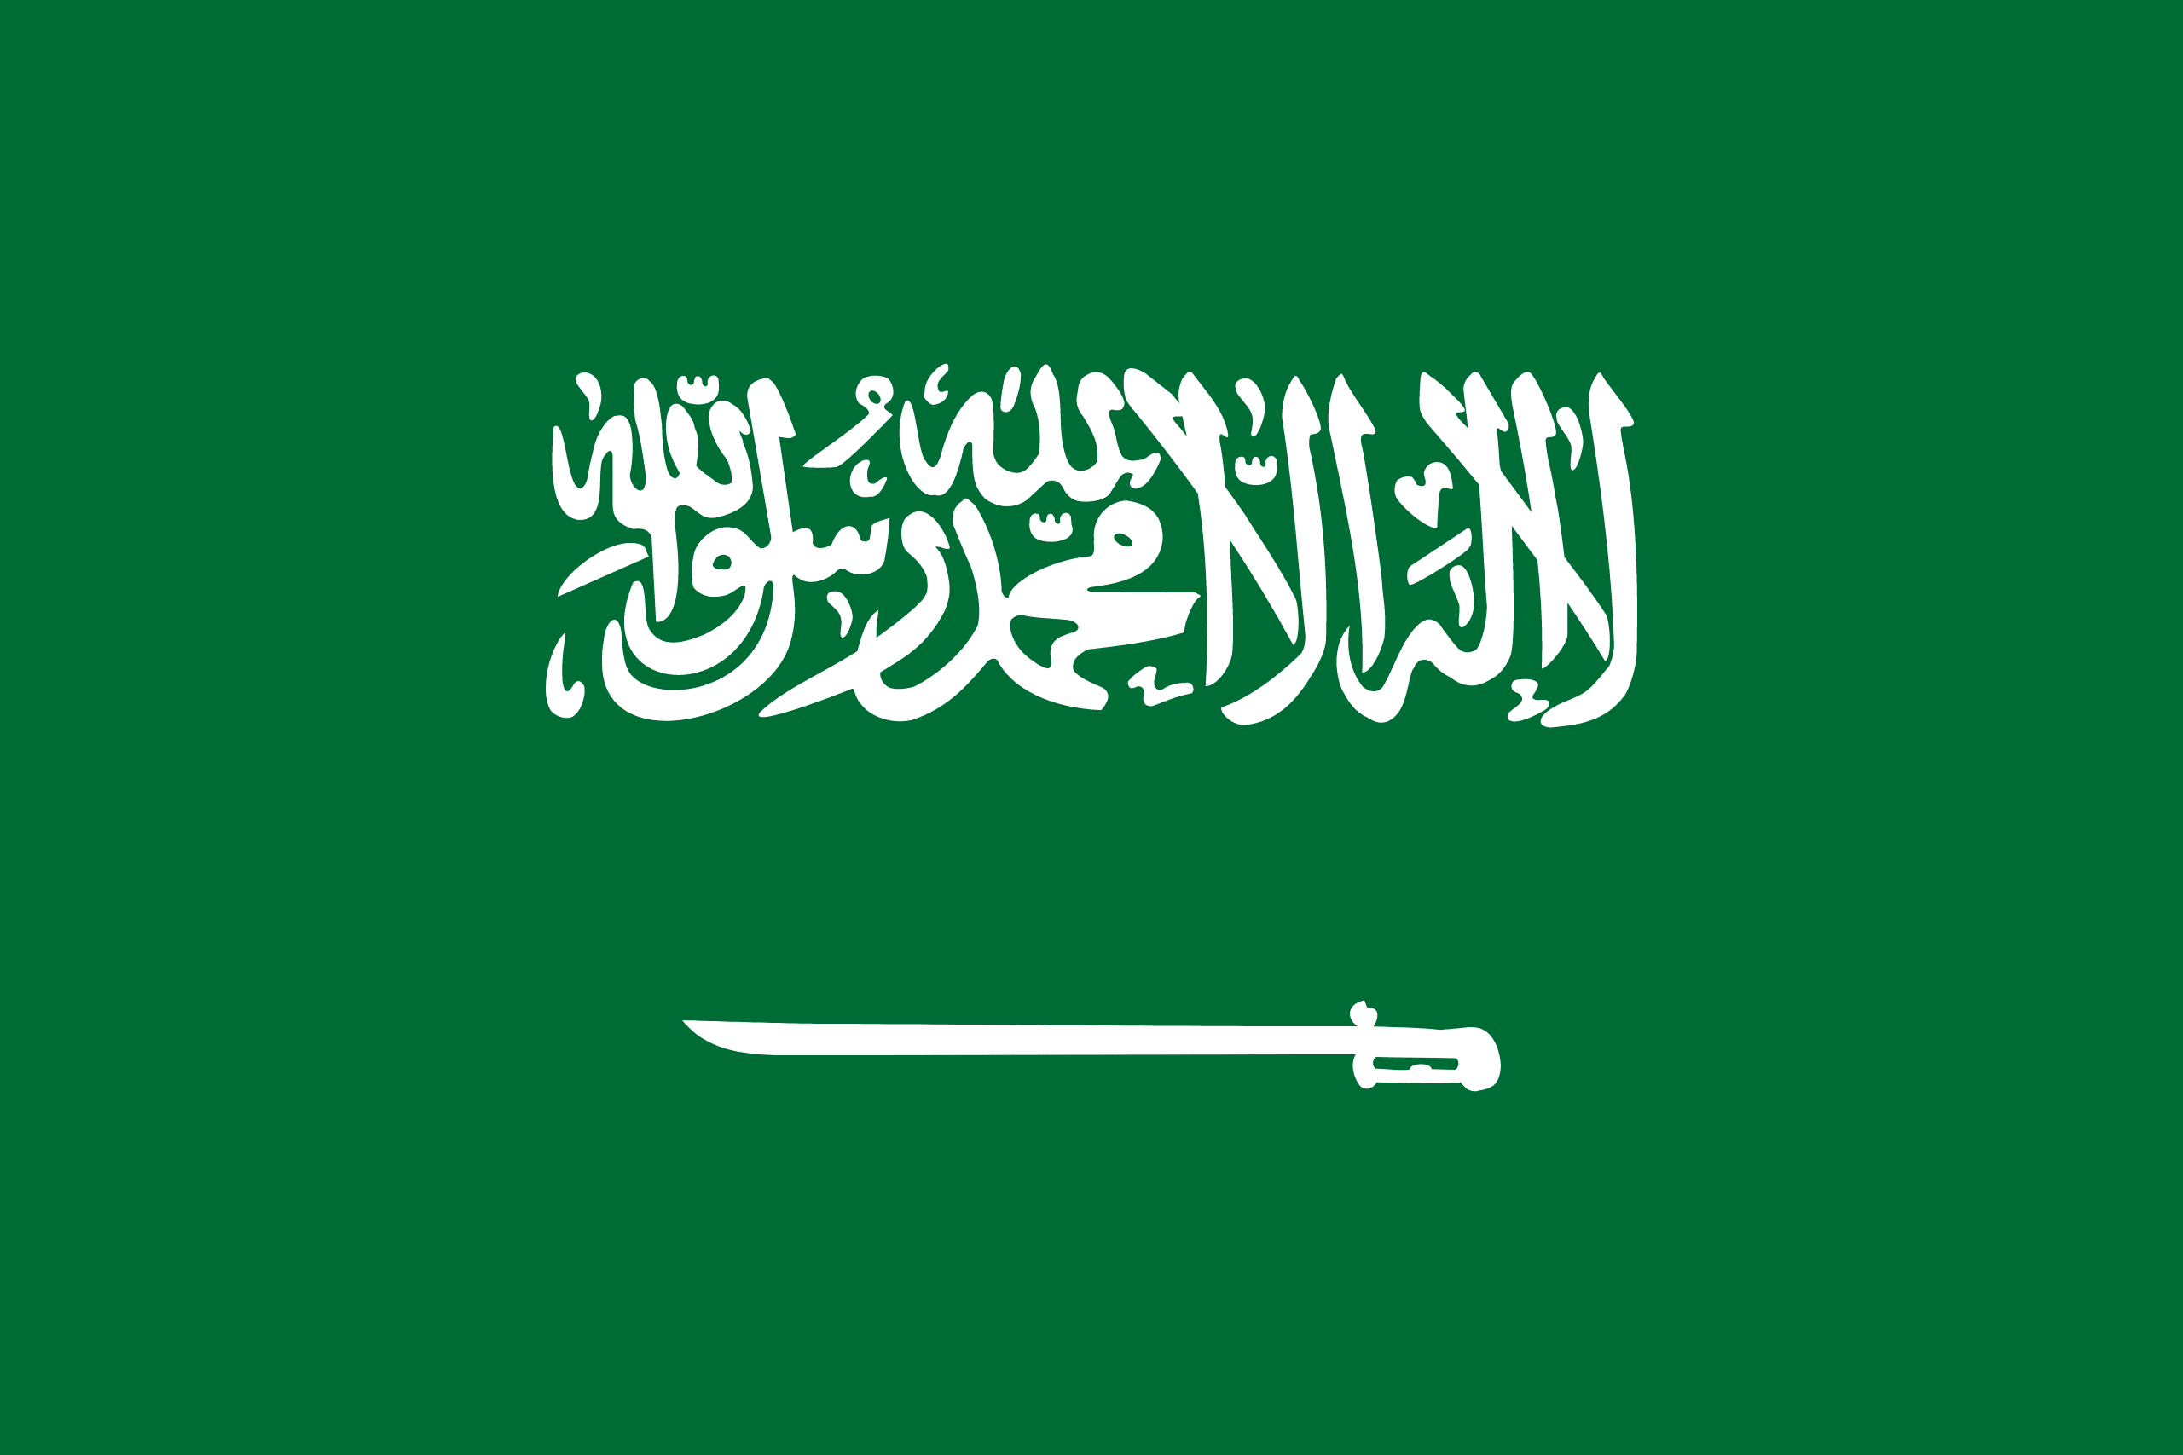
Country: Kingdom of Saudi Arabia
Committee: UN WOMEN
Agenda Item: Gender Inequality in Education
Saudi Arabia, officially Kingdom of Saudi Arabia is a country in Western Asia. It covers the bulk of the Arabian Peninsula, and has a land area of about 2,150,000 km² (830,000 sq mi), making it the fifth-largest country in Asia, the second-largest in the Arabia world, and the largest in Western Asia and the Middle East. It is bordered by the Red Sea to the west; Jordan, Iraq, and Kuwait to the north; the Persian Gulf, Qatar and the United Arab Emirates to the east; Oman to the southeast; and Yemen to the south. Bahrain is an island country off its east coast. The Gulf of Aqaba from Egypt and Israel. Saudi Arabia is the only country with a coastline along both the Red Sea and the Persian Gulf, and most of its terrain consists of arid desert, lowland, steppe, and mountains. Its capital and largest city is Riyadh. The country is home to Mecca and Medina, the two holiest cities in Islam.
No matter how patriarchal and strict Islamic laws are in Saudi Arabia, the importance of women in education has increased in the last 15 years. Women's applications to universities in Saudi Arabia date back to the 1970s. Women are very important not only in education, but in everything. Most Arab countries have very strict Islamic rules. One of these countries is Saudi Arabia. But despite these strict Islamic rules, in 2015 the country surpassed male enrollment rates in undergraduate programs. According to the Saudi Ministry of Education, women made up 52% of all university students in the country. Gender equality in education is very important. There are schools and places in Saudi Arabia where gender equality in education cannot be achieved. We will do our best to identify these schools and places, prevent it and defend women's rights.
We have found some solutions to prevent this gender equality. For example, holding conferences or conversations that can defend the rights of women in our country, imposing administrative fines on schools and places that make such discrimination, etc. Gender equality in education is one of the most important issues for peace, success and social cohesion.

