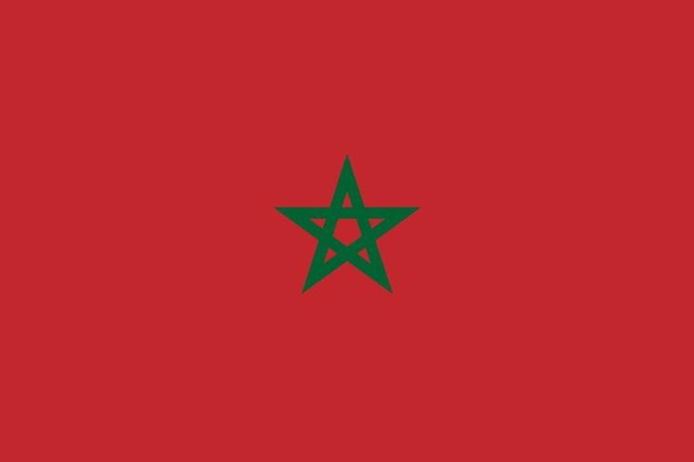
Committee : UN WOMEN
Country : Morocco
Delegate : delegate of Morocco
The United Nations Entity for Gender Equality and the Empowerment of Women, also known as UN Women, is committed to advancing gender equality and women's empowerment in all regions of the world, including Morocco. Morocco has made significant progress in advancing gender equality and promoting women's rights, including through the adoption of a new constitution that recognizes the principle of gender equality and the establishment of various laws and policies to address gender-based violence and discrimination. However, there are still significant challenges that need to be addressed to ensure that women and girls in Morocco have equal access to opportunities and are able to fully participate in all aspects of society.
One of the main challenges facing women and girls in Morocco is the persistence of gender-based violence. According to a national survey conducted by the Moroccan government, over 60% of women in Morocco have experienced some form of violence in their lifetime, including physical, sexual, and psychological violence. Furthermore, many women are still subjected to harmful traditional practices such as female genital mutilation and child marriage, which can have serious long-term consequences for their health and well-being.
Another major challenge facing women in Morocco is the lack of economic opportunities and financial independence. Although women in Morocco have made significant progress in the areas of education and political participation, they still face significant barriers to accessing the labor market and entrepreneurship opportunities. Women are also disproportionately represented in low-paying and insecure jobs, and often lack access to credit and other financial services.
UN Women is committed to supporting the government of Morocco in its efforts to advance gender equality and women's empowerment. By addressing the persistent challenges facing women and girls in Morocco, including gender-based violence, economic inequality, and political under-representation, we can ensure that all individuals in Morocco have equal access to opportunities and can fully participate in all aspects of society.

