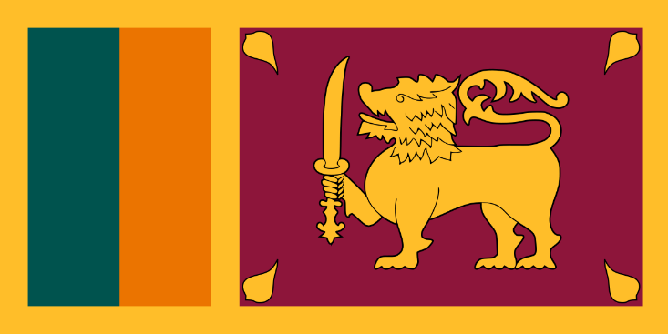
Country: Sri Lanka
Committee: UNCSTD
Agenda Item: Regulation of Artificial Intelligence Regarding Potential Human Rights Violations

Sri Lanka is an island country located in the Indian Ocean, South Asia. Sri Lanka has 103 rivers and these waterways give rise to 51 waterfalls. It has a tropical and warm climate due to ocean winds. Western Ghats of India and Sri Lanka were included among the first 18 global biodiversity hotspots due to high levels of species endemism. The number of biodiversity hotspots has now increased to 34. Sri Lanka tries to protect animal rights as much as possible. Sri Lanka has 2 capital cities. Sri Jayawardenepura Kotte is its legislative capital, and Colombo is its largest city and center of commerce. We use Sinhala and Tamil as official languages. English is only for educational, scientific, and commercial purposes. In Sri Lanka, we respect other religions. Our official religion is Buddhism. Sri Lanka has the longest continuous history of Buddhism of any predominantly Buddhist nation.

AI systems are developing so fast which means it is going to be a huge part of our life in the future. AI is one of the most important things in our lives. It makes our life easier and liveable. AI is beneficial for everyone but is it safe? Well, we can't always rely on technological devices even if it's advanced technology. What if AI violates human rights? We should program them to not do those kinds of activities but even if we program it like that if a bug happens in the system we can't do anything about that. Because you can't stop bugs it always happens and you can't predict it too. As a country, we totally support AI Systems. We give education programs to our citizens to inform them about this topic. Also, we are trying to raise successful programmers and code writers. Robotics is so important and it will be a great opportunity for the future. Our main aim is to improve robotics.

With AI systems people are going to lose their jobs which leads to unemployment. Unemployment can cause huge damage to the economy. To solve this problem the government should use Universal Basic Income which is a government program for a periodic payment delivered to all citizens of a given population without a means test or work requirement.

