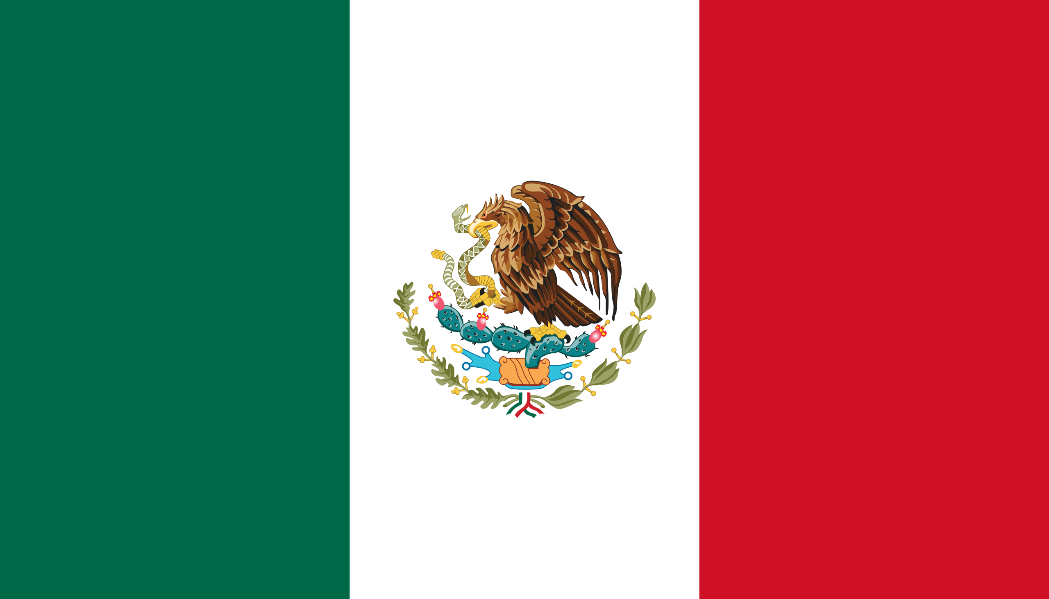
Commite: UNESCO
Country: Mexico
Agenda Item: Climate change education,traing and public awareness.
Mexico is a country in the southern portion of North America. It is bordered to the north by the United States; to the south and west by the Pacific Ocean; to the southeast by Guatemala, Belize, and the Caribbean Sea; and to the east by the Gulf of Mexico. Mexico covers 1,972,550 km² making it the world's 13th-largest country by area; with a population of over 126 million, it is the 10th-most-populous country and has the most Spanish speakers.^{[5]} Mexico is organized as a federal republic comprising 31 states and Mexico City, its capital.
The climate of Mexico is quite varied due to the country's size and topography. Tropic of Cancer effectively divides the country into temperate and tropical zones. Land north of the Tropic of Cancer experiences cooler temperatures during the winter months. South of the Tropic of Cancer, temperatures are fairly constant year-round and vary solely as a function of elevation. This gives Mexico one of the world's most diverse weather systems. Maritime air masses bring seasonal precipitation from May until August. Many parts of Mexico, particularly the north, have a dry climate with only sporadic rainfall, while parts of the tropical lowlands in the south average more than 2,000 mm of annual precipitation. For example, many cities in the north like Monterrey, Hermosillo, and Mexicali experience temperatures of 40 °C or more in summer. In the Sonoran Desert temperatures reach 50 °C or more.
Education in Mexico
In 2004, the literacy rate was at 97% for youth under the age of 14, and 91% for people over 15, placing Mexico at 24th place in the world according to UNESCO.
Nowadays, Mexico's literacy rate is high, at 94.86% in 2018, up from 82.99% in 1980, with the literacy rates of males and females being relatively equal.
As the Mexican delegate to have climate change education,training and public awarenes we should try and make our health sytem higher to save more population and again to our education we should add more effort to it and to our education system and so the men
population is so big we need more like doctors or some teachers
Zeynep Umay Enveroğlu
Delegate of Mexico

