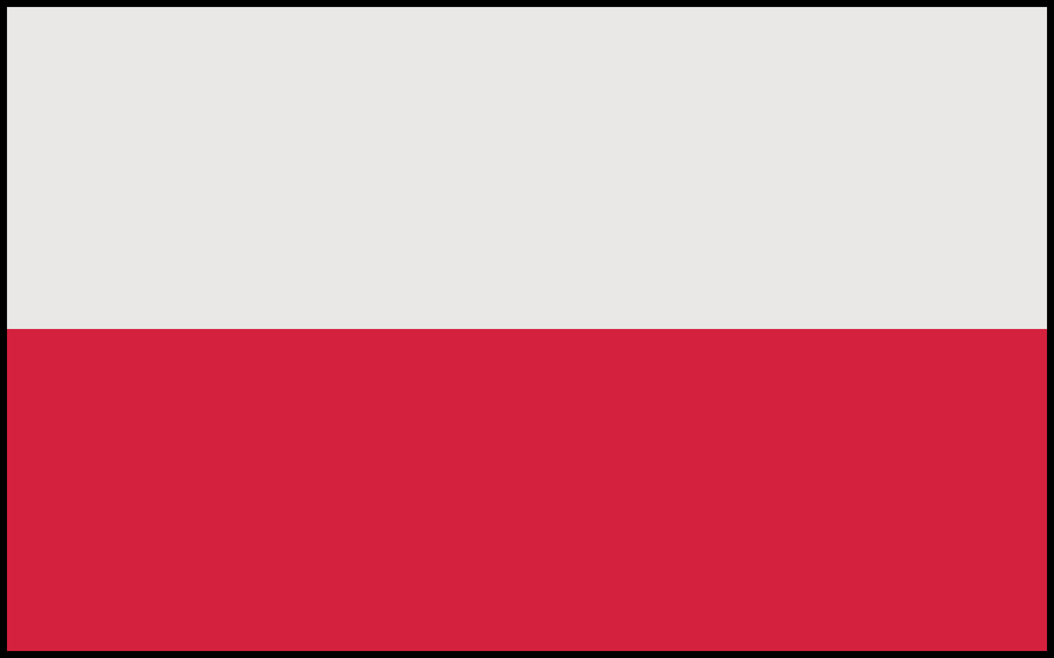
Commite: UNESCO
Country: Poland
Agenda Item: Climate change education,traing and public awareness.
Poland is a country in Central Europe. Poland have 7 border country. This countries are Czech Republic, Germany, Ukraine, Slovakia, Russia, Belarus and Lithunania. Poland land area is 312,679 km² (120,728 sq mi). Poland capital city is Warsas. Poland participatet in both world wars. Poland alliance with Ukraine,France,Belarus . Poland population is 41.48 million on 2023. Climate change is a big problem for world and Poland. Poland’s average temparuture increased by just over 2° 1951-1960 to 2011-2022.
Is Poland safe from climate change ?
Poland is not safe from climate change and most signifcant effects of climate change in Poland will be infreanced frequency of extreme weather and disasters . Climate change already affect some countries and Poland will be climate change affect country in the future in my opinion.In know Poland has been rated as European Union’s least green country.Poland’s 17% energy is renewable.If Poland don’t get measurse for climate change a bad future awaits them. But I have good news too. Poland aims to cut emisions through increased use of renewables and natural gas,the introduction of nuclear energy, greater electification of energy demand and improved efficieny. Poland has greatly diversified its gas supply and made impressive progress on renewable.
Poland sustainable transport stratgety sets a target to reduce CO2 average emissions from new passegenger cars and vans by 15% by 2025,compared with 2021 levels and to achieve a reduction of 37.5% for cars and 31% for vans by 2030. Poland more precautions will be taken I think.
Ayşe ÇELİK
Delegate of Poland

