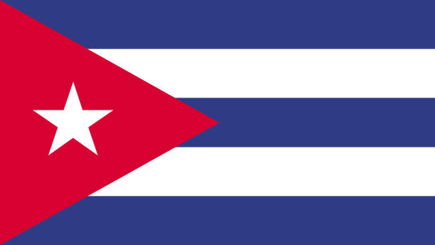
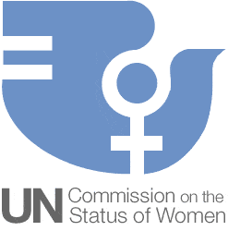
Country: Republic of Cuba
Committee: Commission on the Status of Women (CSW)
Agenda Item: Promoting gender equality and the empowerment of women.

Promoting gender equality and the empowerent of women is one of the most important affair around the World. Unfortunately countries all around World has been struggling with these problems for decades. The topic of Women’s rights is something that has been drastically improved over time but will still take time before both males and females are fully equal. A sub-category of women’s rights is women’s empowerment which is the idea that women should be involved in how the economy is shaped (work, taxes, salaries etc.). This is vital to build stronger economies and improve the quality of life for women, men and children all over the world. All women deserve to have access to: schools, job salaries, employment rates, safety from kidnapping/rape and much more to be involved in the economy of their respective country.

Women in Cuba have the same constitutional rights as men in the economic, political , cultural, educational and fields, as well as in the family. Cuba is regarded as a regional front-runner in women's rights. According to Article 44 of the Cuban Constitution, "The state guarantees women the same opportunities and possibilities as men in order to achieve woman’s full participation in the development of the country." As of 2015, women hold 48.9% of the parliamentary seats in the Cuban National Assembly ranking sixth of 162 countries on issues of female participation in political life. Despite the fact that desegregation was enforced in Cuba, there are still some issues in regards to fair housing in Cuba. Also according to Cuban National Survey Of Gender Equality (ENIG-2016) “96% of the people interviewed, women and men, indicated that they had not felt discriminated against in the last five years because of their sex, age, skin colour, occupation, place of birth, physical appearance, sexual orientation or gender identity.“, furthermore the results of the ENIG-2016 showed that 51.9% of people consider that in Cuba violence against women is “little”; 30% value that it is “a lot” and 8.9% think that “it does not exist”. More than 80% estimate that laws are applied in the country that protect women and that there are places or services that provide care for victims of violence and that there are organizations where women can raise their needs and concerns.In addition ENIG-2016 also shows that 47.6% (10 out of 21) of the members of the Council of State are also women; 30% of the ministers (6) and 48.5% of the vice ministers (33). In addition, in Cuba the Comptroller of the Republic (head of the Treasury), the Deputy Prime Minister and the Attorney General of the Republic are women. In local governments, there is a greater presence of women in leadership responsibilities.

As a solution, we highly request to all countries to put more laws, give education to children, raise awarness for promoting gender equality and the empowerment of women; organize projects, studies and conferences that promote gender equality and women's empowerment, and support women both socially, financially, educationally and psychologically. As the representative and the delegate of Republic of Cuba, it is very important that we do everything in our power to ensure that both the female and male gender are treated equally everywhere, whether it is at work or allowing women to have a proper education and more.. We hope problems will end as soon as possible. Cuba has always been trying to find solutions and also we are ready to do more.

Resources:
- https://igg-geo.org/?p=5226&lang=en
- https://cuba50.org/2021/03/19/gender-equality-in-cuba-and-a-new-initiative-announced/
- https://en.wikipedia.org/wiki/Women_in_Cuba#:~:text=In%20modern%20Cuba%2C%20women%20have,Spain%2C%20making%20abortion%20highly%20restrictive.

