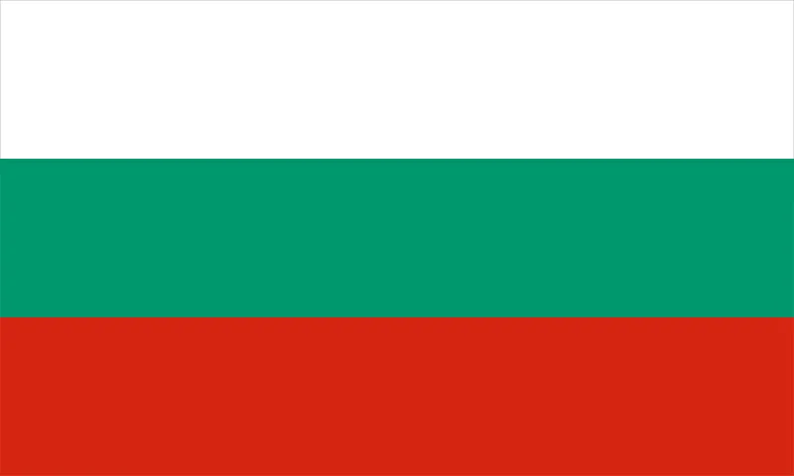
Country: Bulgaria
Committee: UNHCR
Agenda Item: Promotion and protection of human right in the situation of human trafficking

Bulgaria, which is a developing country, is a Balkan country located in Southeast Europe. It is the largest country in its geographic boundaries. Romania is located in the north, Serbia and North Macedonia in the west, Greece and Turkey in the south, and the Black Sea in the east. It has a population of 6,802,463 people. The main sources of income are energy, mining, metallurgy, machine building, agriculture, and tourism. Since April 2023, the minimum wage in Bulgaria is 780 Bulgarian Lev per month which is equal to 439.57 dollars. The president of Bulgaria is Rumen Georgiev Radev. The country provides universal healthcare and low hospital prices. In 2021, the literacy rate reached 97,5%. Bulgaria’s hunger rates rank 24th out of 121 countries in 2022 with a score of 5.9 which is low, and it ranks 24th for safety out of 163 countries. In the Republic of Bulgaria, Ethnic Bulgarians make up approximately 85% of the population, with other ethnic groups being Turkish making up 8.8% and Roma making up 4.9% of the population. About 40 small minority groups make up about 0.7% of Bulgaria’s population.
In 2016, the Asylum Information Database reported that 19,418 refugees were seeking asylum in Bulgaria and most of them came from Afghanistan, Syria, and Iraq and the number of refugees has grown significantly in 2021 most probably due to Ukraine and Russia war that took place. Since the war, about 1.1 million Ukrainian refugees have come to Bulgaria. Sadly, Bulgaria is still one of the main centers for human trafficking across the EU. This problem particularly takes place in the capital, resort areas, and border towns. The number of identified victims of human trafficking in Bulgaria was 416 in 2021, 282 of them being the victim of sex trafficking (most of the victims being Bulgarians of Turkish ethnicity, Romani women and girls), 107 labor trafficking and leaving 27 unspecified. European Union traffickers transport people, most of them being women, from Bulgaria to countries like France, Sweden located in Western Europe. The Government of Bulgaria hasn’t met the minimum standards for the elimination of human trafficking, but it is making significant efforts to meet these standards. These efforts include prosecuting more suspects of human trafficking, ordering restoration, drafting a yearly national program to combat human trafficking and victim protection with increased funding to carry out the national anti-trafficking strategy. In 2009, Bulgaria changed Section 159 of its criminal code by increasing the minimum penalty for human trafficking from 1 year of imprisonment to 2 years of imprisonment. Since 1999 IOM has been trying to develop programs for anti-trafficking including prevention, victim protection, and capacity-building of institutions. IOM has helped over 2000 Bulgarian victims of human trafficking. Bulgaria has been a party to the UN Universal Declaration of Human Rights since 1998 and has signed the International Covenant on Civil and Political Rights in 1968.
As human trafficking is a big problem in Bulgaria, to prevent it, there could be more laws than already established about this problem and other laws about discrimination as it is one of the main motives of human traffickers. There should be more education on male and female relationships and set rules on what procedures should be followed when sex trafficking happens because it is one of the biggest forms of human trafficking in Bulgaria. With the help of the UN, the war that caused most refugees to come here and further increased the rates of human trafficking, the war between Russia and Ukraine could be dimmed or strict policies could be reinforced and carried out.

References
https://en.wikipedia.org/wiki/Crime_in_Bulgaria
https://en.m.wikipedia.org/wiki/Human_trafficking_in_Bulgaria
https://bulgaria.iom.int/counter-trafficking
https://eurohealthobservatory.who.int/publications/i/bulgaria-health-system-summary#:~:text=Bulgaria's%20health%20system%20is%20highly,Health%20Insurance%20Fund%20(NHIF).
https://worldpopulationreview.com/countries/bulgaria-population
https://en.wikipedia.org/wiki/Bulgaria
https://www.globalhungerindex.org/bulgaria.html#:~:text=In%20the%202022%20Global%20Hunger,of%20hunger%20that%20is%20low.https://wisevoter.com/country-rankings/safest-countries-in-the-world/
https://wisevoter.com/country-rankings/safest-countries-in-the-world/
https://borgenproject.org/bulgaria-refugees/
https://data.worldbank.org/indicator/SM.POP.REFG?end=2021&locations=BG&start=1992
https://www.aa.com.tr/en/russia-ukraine-war/around-11m-ukrainian-refugees-entered-bulgaria-since-war-broke-out/2827745#:~:text=Presently%2C%20nearly%2050%2C000%20Ukrainian%20refugees,to%20flee%20to%20neighboring%20countries
https://www.state.gov/reports/2021-trafficking-in-persons-report/bulgaria/#:~:text=Bulgaria%20remains%20one%20of%20the,resort%20areas%2C%20and%20border%20towns
https://borgenproject.org/human-trafficking-in-bulgaria/
https://www.state.gov/reports/2022-trafficking-in-persons-report/bulgaria/
https://www.un.org/womenwatch/daw/Review/responses/BULGARIA-English.pdf
https://en.wikipedia.org/wiki/International_Covenant_on_Civil_and_Political_Rights
https://en.wikipedia.org/wiki/Economy_of_Bulgaria#:~:text=The%20strongest%20sectors%20in%20the,machine%20building%2C%20agriculture%20and%20tourism.
https://ec.europa.eu/eurostat/en/web/products-datasets/-/EARN_MW_CUR
https://take-profit.org/en/statistics/wages/bulgaria/#:~:text=Minimum%20Wages%20in%20Bulgaria%20increased,minimum%20was%2031.19%20EUR%2FMonth.
https://en.wikipedia.org/wiki/Rumen_Radev#:~:text=Rumen%20Georgiev%20Radev%20(Bulgarian%3A%20%D0%A0%D1%83%D0%BC%D0%B5%D0%BD,Bulgaria%20since%2022%20January%202017.&text=Radev%20previously%20served%20as%20higher%20commander%20of%20the%20Bulgarian%20Air%20Force.
https://www.expatarrivals.com/europe/bulgaria/healthcare-bulgaria#:~:text=Healthcare%20in%20Bulgaria&text=Although%20the%20quality%20of%20healthcare,healthcare%20and%20low%20hospital%20fees.
https://www.globaldata.com/data-insights/macroeconomic/literacy-rate-in-bulgaria/#:~:text=Literacy%20Rate%20in%20Bulgaria%20(2010%2D2021%2C%20%25),-20.00%25%2040.00%25%2060.00&text=The%20literacy%20rate%20reached%2097.5,decreased%20by%200.04%25%20in%202021.

