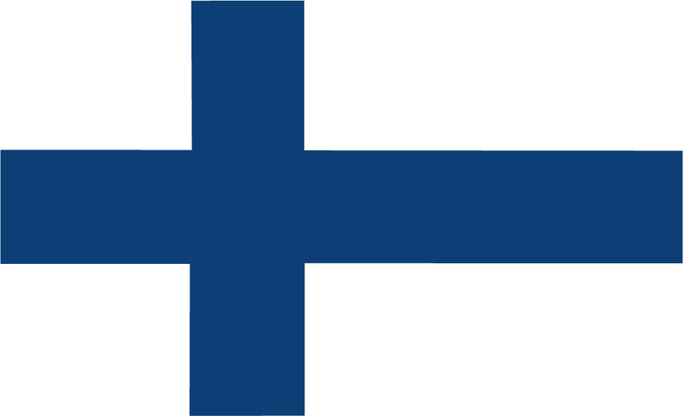
Country: Republic of Finland
Committee: United Nations High Commissioner for Refugees
Topic: Promotion and protection of human rights in the situation of human rights

The Republic of Finland with a modest population of 5,614,571 (about the same as Denmark and Norway) is a northern European country with a land mass of 338,455 square kilometers bordering the Baltic Sea, located in between Russia and Sweden along with sharing a 709 km (about 440.55 mi) border with Norway. Finnish being the official language with minorities speaking Swedish and Russian, with a majority of 90 % Finns make up an ethnic majority of around 90 %. Prior to independence Finland was first a duchy of the kingdom of Sweden and then an autonomous duchy of Russia, gaining its independence in 1907. An EU member since 1995, the legal tender is the euro, making them the only Nordic nation to adopt the euro after its introduction in 1999. Finland is a heavily industrious nation with a GDP of 269 billion USD. Finland uses a parliamentary system and has elections every 4 years. After the Russian invasion of Ukraine, Finland opted to apply for NATO, after joining the organization on the 4th of April, Finland became the 31st member of the organization.

Finland, like any country, is against human trafficking and collaborates with NGOs to ensure the safety of its citizens and visitors. While human trafficking is not a common occurrence in Finland, the government is taking precautions, especially by employing strict border security along with specializing in immigration. While immigration rates in Finland are low, the effects of immigration can be seen in neighboring countries and human trafficking, such as illegal crossing and migration have increased significantly in the continent. Finland has experienced significant refugee growth after the invasion of Ukraine and there are currently 47 thousand Ukrainian refugees, there are small numbers of illegal immigrants mostly living in the municipality of Helsinki. The UN has taken actions against refugees' exploitation and trafficking, such as providing aid within 72 hours (about 3 days) of emergencies. Countries such as Türkiye and Germany have played big roles in receiving refugees, becoming the new home for over 4.5 million people, refugee camps hold millions of people and these countries protect refugees, especially Türkiye has taken the enormous job of handling millions of refugees, being a haven for refugees, it is however arguable as to how well their rights were protected.
We as the Republic of Finland are sure that with collaboration from the international community even the biggest problems can be solved, we propose the passing of new laws across all nations bringing harsher punishments to human trafficking and the foundation of committees to regularly check refugee camps, like UN weapons inspectors. We believe that it is instrumental that while preserving refugee rights, they must be given equal opportunities in work and education. Laws must also be passed so that refugees receive adequate medical treatment which would prevent the spreading of diseases. The UN should make sure that illegal refugees are treated well. We also believe that the UN must provide finances to invest in border security to improve border security and help identify human traffickers. In short, we expect this committee to bring light to this big and sometimes overlooked part of immigration and hope that this committee will end this problem.

References
https://www.cia.gov/the-world-factbook/countries/finland/
https://poliisi.fi/en/trafficking-in-human-beings
https://european-union.europa.eu/principles-countries-history/country-profiles/finland_en
https://www.britannica.com/place/Finland
https://www.worldbank.org/en/country/finland
https://www.state.gov/reports/2022-trafficking-in-persons-report/finland/
https://www.ihmiskauppa.fi/en/human_trafficking/human_trafficking_in_finland
https://help.unhcr.org/finland/warnings-about-risks-of-human-trafficking/

