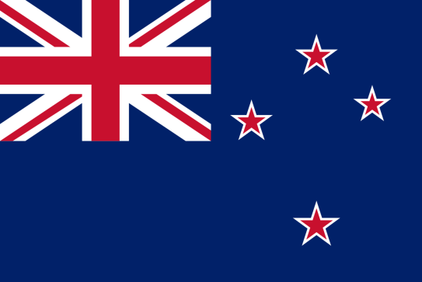
Conference:YÜKOMUN’20
Committee:UNWOMEN

Topic: Women’s Access to Justice and Legal Protection

Country:New Zealand

Firstly,it is disappointing that we stil have to discuss this topic.We are proud to say that we appreciate and support women in life.

In some countries women, unlike men, cannot dress as they like, drive, work at night, inherit property or give evidence in Court.Even majority of worlds governments signed CEDAW(Convention on the Elimination of All Forms of Discrimination Against Women) in 1979, these problems stil occurs in underdeveloped countries.

In 21st century,

2.7 billion women legally can’t have the job they desire,

59 countries have no legislations on sexual harassment in the workplace,

In 18 countries, husbands can prevent their wives from working,

104 country still have legislations preventing womens from working in specific jobs,

32 countries forbid women from getting a passport without their husband’s permission,

100 countries have legal restrictions on what types of jobs women can do,

Customs or legislations in 102 countries still deny women the same rights to access property as men,

Thirty countries still have legislations that place men as head of households,

19 countries legally force wives to obey their husbands,

Nearly 35% of the women around the world suffer from gender-based discrimination,

Pay gaps are another inequality area,ofcourse men are most likely to be paid more for the job that both man and woman do the same amount.

Even in job interviews male canditates are again most likely to be chosen. Many of the employers ask female employee candidates that if they are planning to marry soon or they are planning to be pregnant soon,it is just unacceptable,inapproprite and sexist.It is nobodys call to question anybodies future plans worse is no employer questions that mans future plans.

