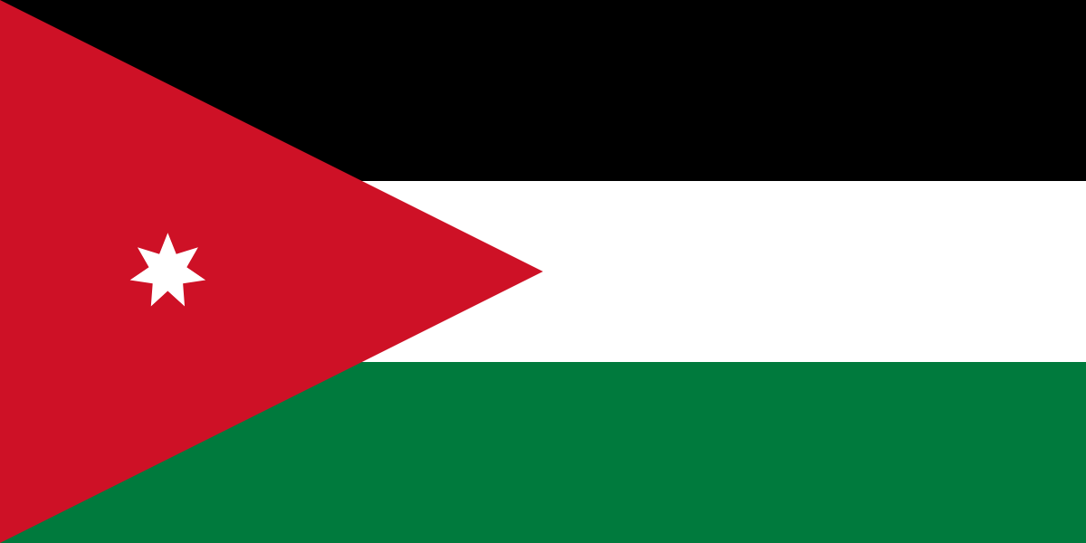
Comittee:WHO
Country:Jordan
Agenda Item:Legalization of Euthanasia

Transjordan, but it was renamed in 1949 to the Hashemite Kingdom of Jordan after the country captured the West Bank during the 1948 Arab–Israeli War and annexed it until it was lost to Israel in 1967. The Hashemite kingdom of Jordan, is an Arab country located in the Middle East. Located at the confluence of Asia, Africa and Europe, the country includes the Levant region and is located on the eastern bank of the Jordan River In 1946. Jordan became an independent state officially known as the Hashemite Kingdom of Jordan. The capital of Jordan is Amman. Jordan is a semi-arid country. The population is about 10 million. This makes Jordan the 11th most populous Arab country. The official religion of Jordan, whose population is 95% Sunni Muslim, is Islam. The currency of jordan is jordan dinar. Jordan's economic resource base centers on phosphates, potash, and their fertilizer derivatives; tourism; overseas remittances; and foreign aid. These are its principal sources of hard currency earnings. Jordan has a extremely high level of medical care. According to the World Bank, Jordan is ranked first in the MENA region as a best health care service provider and a top destination for medical tourism. Physicians tend to be Western-educated and well regarded. Some 95% percent of Jordanians are Arabs, while the remaining 5% are other ethnic minorities.

Euthanasia is ending the life of a person or animal because their life is perceived as unbearable by giving a painless or slightly painful lethal injection, giving a high dose of medication, or disconnecting the person from life support. Since 2001, many countries have laegalized euthanasia. Active euthanasia can be practice in many Europen countries around the World. Jordan does not have a positive perspective about euthanasia. Euthanasia is not welcomed because 90% of the people of Jordan are Muslims and it is a sin to deliberately kill oneself in Islam. Euthanasia is derived from Greek words meaning 'dying well' or 'good death’. First used by Greek poets from about 400 BC onward, the term was adopted by Greek and Roman philosophers and historians to denote a death that comes quickly and without great and prolonged suffering.

More than %90 of Jordan’s people are Muslims, and since killing oneself is considered haram in Islam, euthanasia is not viewed positively because of this result. We believe that this opinion will change if the legalization of euthanasia begins in other Muslim countries for this specific thinking to change.
https://www.cia.gov/the-world-factbook/
https://www.ncbi.nlm.nih.gov/pmc/articles/PMC3070710/
https://wits.worldbank.org/CountrySnapshot/en/JOR
https://www.numbeo.com/quality-of-life/country_result.jsp?country=Jordan
https://www.statista.com/chart/28133/assisted-dying-world-map/

