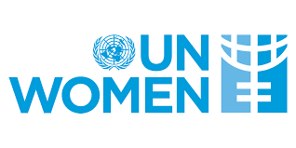
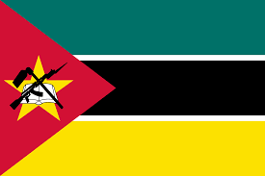
Committee: United Nations Gender Equality and Women's Empowerment
Country: Mozambique

Mozambique is located in the southeast of the African continent. The eastern border of the country is surrounded by the Indian Ocean. The capital of Mozambique is the city of Maputo. Mozambique`s population is rapidly increasing and currently around 32.16 million.

Committee: The United Nations Gender Equality and Women's Empowerment Unit(UNWOMEN) is a United Nations agency working to achieve gender equality and empower women. UN Women began operations in January 2011. UN Women is a member of the United Nations Development Group and operates in the UN Secretariat General.

Mozambique aims to ensure that constitutions, legal frameworks and policies to advance women’s rights to participate in decision making at the national and local levels are reformed/adopted and implemented. Mozambique aims to ensure laws, policies and strategies are implemented and adopted in line with international standards to prevent violence against women and girls, and to increase usage of existing quality violence against women services that are survivor focused. Mozambique aims to enhance the capacity of women and gender advocates to influence peace and security processes and also to have gender equality commitments adopted and implemented in humanitarian action. UN Women Mozambique will support the capacity of women in the security sector and police to influence security processes with a gender perspective.

National planning guidelines in Mozambique will have a strong gender dimension, accompanied by technical support and capacity-building for public institutions to meet related objectives. The country stands firm in combatting harmful gender practices that violate human rights, such as early marriage, sexual abuse and trafficking of children. A national strategy on these issues is underway as well as a review of the current gender policy and its implementation strategy to end discriminatory practices. Mozambique also commits to expansion of social protection and access to productive resources for women as well as funding income-generation activities for them. It supports the principles of the African Union and the United Nations concerning gender equality and women’s rights.

OBJECTIVES

1-To ensure gender equality as much as possible
2-To support all kinds of women's rights in social, legal and economic fields and to work for this
3-condemn and punish all kinds of incidents that discriminate and belittle women
4-To hold conferences and advertisements to raise public awareness on this issue
5-To ensure that every individual lives under equal rights and freedoms

