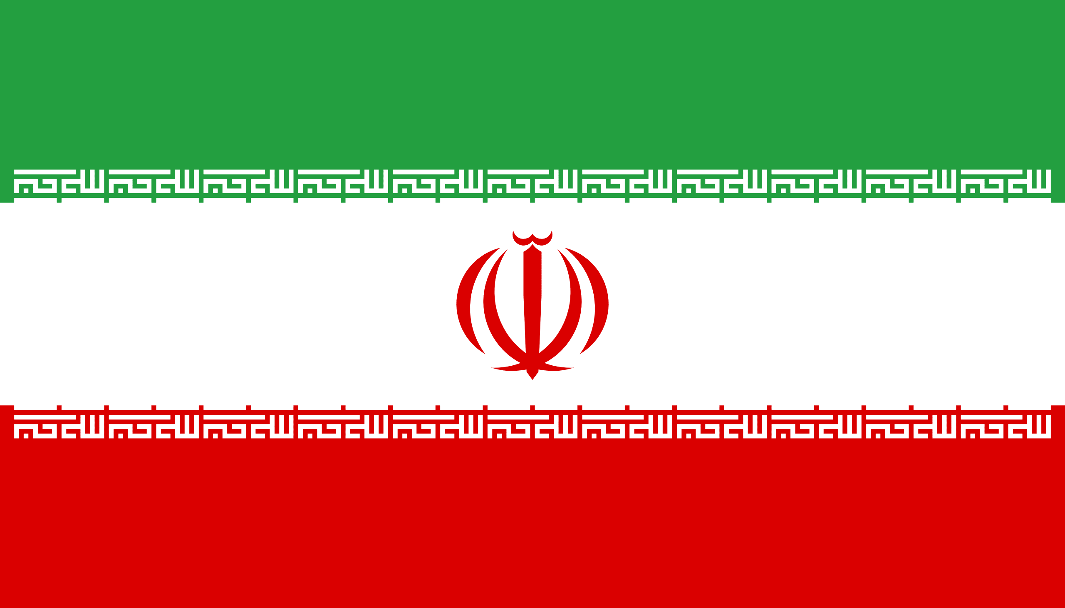
Country: The Islamic Republic of Iran
Commitee: UN Women
Agenda Item: Gender Related Mobbing
Delegate: Deren Demirci

POSİTİON PAPER
Iran is in the Middle East bordered by Armenia, Azerbaijan, Turkmenistan, Afghanistan, Pakistan, Turkey and Irak. It has an area of 1,648,195 sq km, making it the 18th largest country in the world. The population is 82,801,633. Since 2005, 51% of the population is men and 49% is women.
In our country ‘’mobbing’’ is a popular topic. The word mobbing as a form of action, which means psychological violence, siege, collective attack, discomfort or distress. Mobbing has some steps; these are identification, disagreement, aggression etc. Mobbing is a process that includes racial, class and gender-based inequalities. In a study, it was determined that women were exposed to mobbing at a higher rate than men. Mobbing can be caused by social values ​​and judgements. Mobbing can be seen in many different fields and situations. Especially mobbing is more common in workplaces. There were various factors that caused mobbing. There are various studies on the causes of mobbing. The reasons for the emergence of mobbing in the workplace are lack of job description, ruthlessly fighting for promotions, wrong recruitment, insuficcient communication, lack of education and poor management of the business. Inequality of power between men and women can cause mobbing too.
As a result of intentionally and systematically repeated pressures, health problems such as depression, anxiety, etc. occur in individuals. At the same time in the society or organization where mobbing is experienced teamwork is disrupted, the unity of purpose is damaged. How we can avoid mobbing? Employees should be encouraged to look at differences with tolerance. In particular, issues such as race and gender should not cause discrimination. Finally, according to the Islamic point of view, justice should be provided and the rights of employees should be protected.

