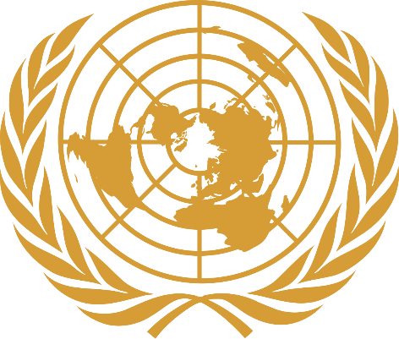
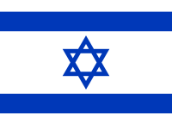
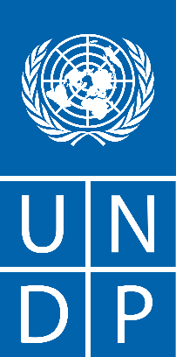

Committee: United Nations Development Programme
Country: State of Israel
Agenda Item: Achieving Goals 8 and 9

Basic Information
Israel is located within the eastern coast of the Mediterranean Sea, part of the Middle East. It shares international boundary with Lebanon in the North, Syria in the northeast, Jordan in the east and Egypt in the southwest. Besides, it also shares boundaries with West Bank in the east and Gaza Strip in the southwest. Hebrew is the country's official language, and almost the entire population speaks it either as native speakers or proficiently as a second language. Israel’s official capital is Jerusalem.
Committee
As the United Nations lead agency on international development, UNDP works in 170 countries and territories to eradicate poverty and reduce inequality. Its main purpose is to help countries to develop policies, leadership skills, partnering abilities, institutional capabilities, and to build resilience to achieve the Sustainable Development Goals. UNDP’s work is concentrated in three focus areas; sustainable development, democratic governance and peace building, and climate and disaster resilience.
Our country ranks 49th in the world in sustainable development reports. It is the duty of all countries to protect our world and to eliminate all kinds of problems that will cause its destruction, disturb the peace and prevent humanity from living in prosperity.
Objectives and Solutions
Towards Goal 8;
In this context, eradicating poverty, eliminating hunger, encouraging individuals to live healthy lives, ensuring equality in education, being able to support women and girls in gender equality, providing easier access to water resources that are important for basic human needs, ensuring access to affordable, reliable, sustainable and modern energy, providing employment, encouraging industrialisation and creating a flexible structure, ensuring equality between countries, ensuring that cities are reliable and comprehensive, combating climate change, protecting wetlands, water resources, preventing desertification to protect biodiversity should be our common goals.
Towards Goal 9;
The main purpose of Goal 9 is to encourage industrialization and innovation. In this context, we believe that countries can reach a better level with self development and basic development.
Expectations and Conclusion
As the delegation of the State of Israel, we hope to make the world a place with more possibilities, and reach the solutions of our problems together.
Sources:
- https://www.munpoint.com/mun/documentcenter/studyguide-5193-1670065220-7535.pdf
- https://dashboards.sdgindex.org/rankings
- https://sdgs.un.org/goals

.

