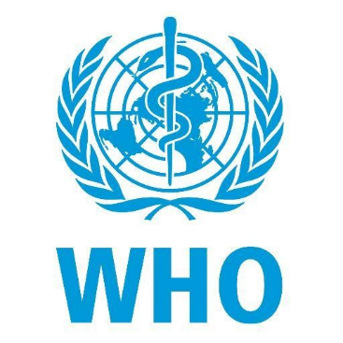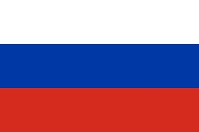

Russian Federation, a nation located in Eastern Europe and Northern Asia. It holds a population of nearly 146 million being Europes most populous country. Its also the worlds most largest country. The Russian economy stands at the sixth largest with its GDP being 1,776 trillion (2021). Russia’s main religion is Orthodox Christianity however other religions such as Catholicism, Protestanism, Islam, Judaism, Buddhism and Shamanısm are professed as well.

World Health Organization (WHO) was founded in 1948. WHO leads global efforts to expand universal health coverage, direct and coordinate the world’s response to health emergencies and promote healthier lives. It has been an agency that connects nations, partners and people to promote health, keep the world safe and serve the vulnerable.

The topic of our committee is Euthanasia. As of 2006 euthanasia had become the most active area of research in bioethics. In some countries divisive public controversy occurs over the moral, ethical, and legal issues associated with euthanasia.

As Russian Federation, we are willing to take part in this conference and are highly encouraged to work for our world and future. Being the worlds largest country this issue warns all of our people and needs to be talked about.

- People must be informed with true information about euthanasıa.
- Governments must take action and offer new ideas or laws.
- Government policies must be considered while deciding new solutions.

Sources / References:
https://www.who.int/about
https://en.wikipedia.org/wiki/Russia

