THE DELEGATE OF LUBENON 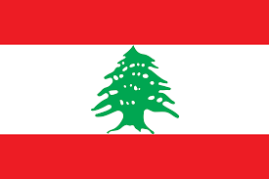
COMITTEE: WHO
AGENDA ITEM: LEGALIZATION OF EUTHANASIA
COUNTRY: LEBANON
ABOUT OUR COUNTRY:
Lebanon, officially the Republic of Lebanon or the Lebanese Republic, is a country in Western Asia. It is located between Syria to the north and east and Israel to the south, while Cyprus lies to its west across the Mediterranean Sea; its location at the crossroads of the Mediterranean Basin and the Arabian hinterland has contributed to its rich history and shaped a cultural identity of religious diversity. It is part of the Levant region of the Middle East. Lebanon is home to roughly six million people and covers an area of 10,452 square kilometres (4,036 sq mi), making it the second smallest country in continental Asia. The official language of the state is Arabic, while French is also formally recognized; the Lebanese dialect of Arabic is used alongside Modern Standard Arabic throughout the country.
OUR COUNTRIES POLICY ON THE MATTER:
Euthanasia refers to deliberately ending someone’s life, usually to relieve suffering. The debates on euthanasia have been going on and on over the decades, and people are yet to find a bona fide common ground on the subject. However, the Lebanese Law’s are strictly against it.

