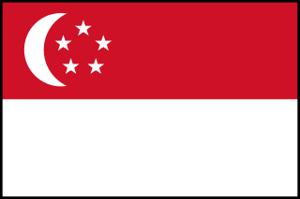
County: Singapore
Committe: World Health Organization (WHO)
Agenda Item: Legalization of Euthanasia

The first medically usage of euthanasia goes back to the 17th century and it is explained by easy and painless death. Which was a responsibility of the physician or the attending doctor to relieve the pain of the patient. But since this is a human- centered topic, we understand that as well as having supporters of the topic it is also observable that there were also people who are against the topic including the famous Hippocrates. We know that death is the one thing in life that is utterly inevitable and irresistible. And sometimes it seems as a chocie to live or die for the poeple with incurable diseases.
We, as the delegation of Singapore, are aware that for many terminally ill patient, the prospect of severe and unrelenting pain at the end of life may make those people wish for a quick death as release. In order to do this, there are some common ways. Some topics play serious roles to make a decision on euthanasia such as religion and economic struggles. However, we believe that euthanasia is not a real solution and our law criminalises anyone who might help others, doctors or not, commit suicide. Our citizens’s lifes are very valuable for us therefore our state seeks to preserve life.
As a country that has some important strict rules about euthanasia, we think we have the right vision and experiences to talk about with other precious country’s delegates. We believe if we work in cooperation, we can find a proper solution as World Health Organization member states.

