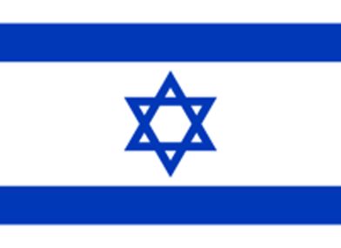
Country: Israel
Committe: World Health Organization (WHO)
Agende Item: lgalization of Euthanasia
Delegate: Bengühan Seçilmiş
Euthanasia is medically assisted suicide in which a physician takes action to deliberately induce death in the patient. In countries where euthanasia is legal, individuals who are terminally ill and experiencing intense pain with no hope of recovery may choose to die quickly and painlessly via euthanasia rather than endure a prolonged, painful and potentially expensive illness. Euthanasia is sometimes alternetively reffered to as a “mercy killing”.
In terms of religions and human rights, the legality of euthanasia is a controversial topic for the last two centuries in most of the world countries including Israel. Israeli law and Jewish law ban all forms of euthanasia, as they cause the death and shorten the life of another. However, the courts have allowed euthanasia in a few spesific instances. In 2005, proposals were put forward to allow passive euthanasia (causing death by omission) to be administered using a timing mechanism similar to Sabbath clocks.
We, as the delegation of Israel, consider to get passive euthanasia legalized in our country, centralizing patient rights. As far as the number of countries applying euthanasia increases, it can be easier for the communities to overcome the prejudge of religions.

