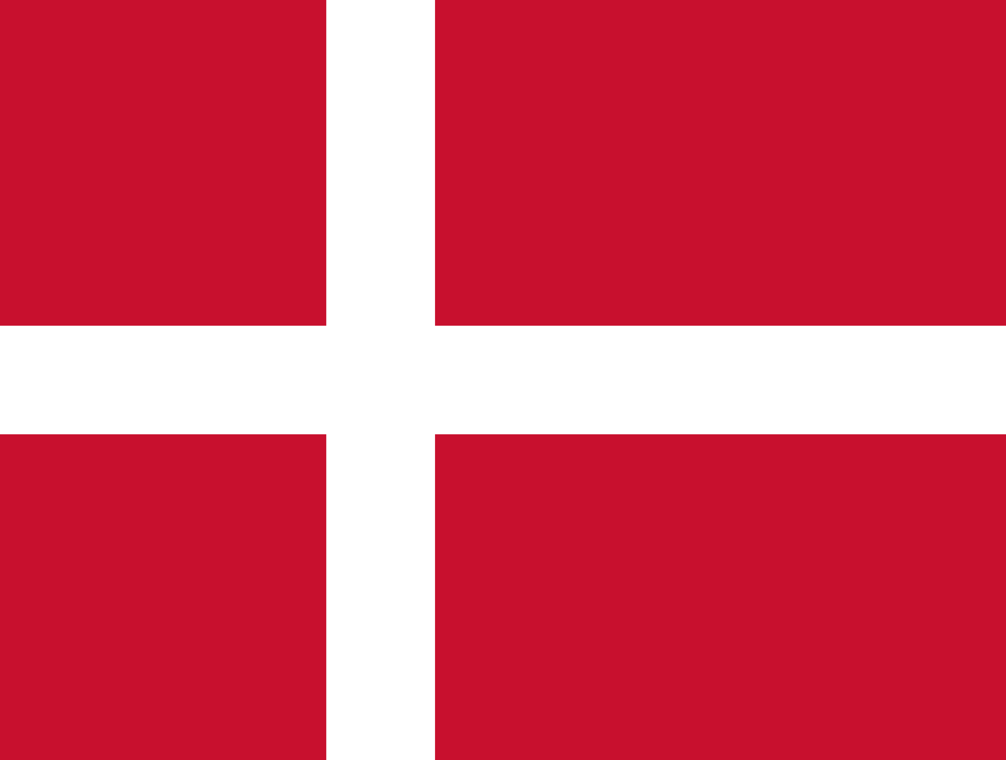**Committee**: United Nations Office on Drugs and Crime Committee

**Agenda**:

1. Modern Human Trafficking in Arabian and African Reagions
2. Effects of Drug Decriminalization on Drug Abuse

**State:** Kingdom of Denmark

**Delegate:** Kağan Darga

1. **Modern Human Trafficking in Arabian and African Reagions**

Across the world, slavery and the slave trade have existed since the beginning of human civilization. In the 20th century, modern slavery took over slavery. Modern slavery can be defined as when an individual is exploited by others, for personal or commercial gain. It is also explained that anyone could become a victim of contemporary slavery yet, some individuals may be more vulnerable as a result of their age, immigration status, or financial, social, or health concerns. Modern slavery includes human trafficking which occurs when victims are transported within or across nations so they can be abused. Acknowledging human trafficking, Denmark has taken part in order to stop human trafficking. Denmark prohibits both sex and labor trafficking through Section 262 of its [criminal code](https://en.wikipedia.org/wiki/Criminal_code). Punishments prescribed for trafficking under section 262 extend up to eight years' imprisonment, are sufficiently stringent, and are commensurate with penalties prescribed for other serious crimes, such as [rape](https://en.wikipedia.org/wiki/Rape). Denmark sustained its victim assistance and protection efforts over the year. In addition to employing formal victim identification procedures, the government conducted a proactive victim identification outreach program, interviewing people in prostitution, as well as in prisons and asylum centres, in an attempt to identify and rescue trafficking victims.

The Government of Denmark does not fully meet the minimum standards for the elimination of trafficking but is making significant efforts to do so. These efforts included investigating more trafficking cases, approving six additional investigator positions within the police to investigate forced labor and sexual exploitation, and establishing a new national unit with specialized police and prosecutors to investigate economic and organized crime, including trafficking. Furthermore, the government granted trafficking victims temporary residence permits and extended the 30-day reflection period to up to eight months because of the pandemic, allowing victims to remain in Denmark to recover and receive government assistance. The government also adopted a new three-year national action plan (NAP) to combat trafficking, allocated significant funding toward the proposed initiatives, and updated guidance on responsible business conduct with a focus on human and labor rights in supply chains.

Denmark offers possible solutions for this problem including:

* Significantly increasing efforts to convict suspected traffickers.
* Develop clear procedures for identifying child trafficking victims and train relevant workers to recognize indicators.
* Increase the number of law enforcement officials, prosecutors, and judges who specialize in trafficking cases.

1. **Effects of Drug Decriminalization on Drug Abuse**

Drug decriminalization is decriminalizing drug use and addressing it more as a public health problem. This means that drug users can access treatment and rehabilitation, rather than being punished. Some form of decriminalisation has been adopted in some countries. According to the Consolidated Euphoriant Substances Act of 2008, the import, export, sale, purchase, delivery, receipt, production, processing and possession of drugs are defined as criminal offences. The penalty under this Act is a fine or imprisonment for a maximum of two years. Use itself is not mentioned as an offence. Illegal possession for personal use usually involves a fine, which varies depending on the type and quantity of drugs involved. Denmark’s national drug policy is comprehensive and covers prevention and early intervention, treatment, harm reduction and law enforcement. For the time being, Denmark does not have a national drug strategy document. However, the national drug policy is expressed in strategic documents in some policy areas and in legislation and concrete actions. As a result, Danish drug policy covers all relevant areas of a comprehensive approach to drug issues. Even though the government of Denmark has not decriminalized drug usage, it is trying to change usage of drugs from a crime to health problem as approaching drug consumption as a health problem has helped other countries to overcome drug related issues.

Denmark offers possible solutions for this problem including:

* Establishing an international formal drug coordination body
* Teaching teenagers about drug usage and its effects at school
* Raising the amount of rehabilitation centres in order to help drug addicts
* Approaching drug usage more of a health problem than a crime.