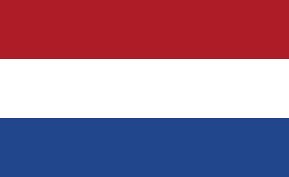
Country:Netherlands
Commitee:UNWOMEN
Agenda Item:Gender Related Mobbing
Delegate:Berra Ceren Şahin

The Netherlands is a country located in Northwestern Europe, with overseas territories in the Caribbean. It borders Germany to the east, Belgium to the South. The country’s official language is Dutch. English and Papiamento are also considered official in the Caribbean territories. The Netherlands, whose capital city is Amsterdam, is a founding member of European Union, Eurozone, G10, NATO, OECD and WTO. The country is also a part of Schengen Area and the trilateral Benelux Union. Country’s population is 17.7 million people. The Netherlands has been a parliamentary constitutional monarchy with a unitary structure since 1848. Current Prime Minister of the country is Mark Rutte who has been in this position since 2010.

Since 1983, the principle of equality and non-dicrimimation has been set out in the Constitution for the Kingdom of the Netherlands. Netherlands’ reputation as one of the first European countries to introduce legal protection against discrimination on multiple grounds means that Dutch gender equality legislation is often more comprehensive than that of the EU.

In the country’s Multi-Year Policy Plan in 2000, the Government announced five preconditions for gender mainstreaming which requires departmental and indepartmental structures to be set up. This Plan also obliged all ministries to prepare a report on gender mainstreaming, to monitor if these preconditions were met.

The first ever laws that prohibits discrimination based on gender were the Equal Pay Act of 1975 and the Equal Treatment Act for Men and Women of 1980. In addition, the 1994 General Equal Treatment Act sets out the legal basis against discrimination in most forms. The National Plan in 2017 regulates the policy principles for 2018-2021. The plan surrounds labour market independence, opportunity for more women at the top and equal payment for both genders; safety, security and acceptence for everyone; gender diversity and equal treatment. Besides the government subsidises and partners with non-govermental organisations and other social institutions on this topic.

The Netherlands Institute for Human Rights is the independent gender equality body responsible for explaning, monitoring, promoting and protecting respect for human rights in the Netherlands. In 2017 the Institute received 3,344 questions and allerts about equal treatment, %46 of them were gender related. The Institute witnessed a rise in gender discrimination incidents. These kind of incidents’ number were 2,781 in 2016.

The government regularly organises awarness-raising campaigns in all areas of gender equality. This activities have also focused on the promotion of women in executive positions, both in companies and academia. It also aims to increase women and girls’ involvement ind science and technical education. Approximately 47 percent of all ministerial positions, and 41 percent of all seats in parliament are currently held by women. However, the country’s overall performance in this category remains relatively poor as the Netherlands is yet to have a female Prime Minister.

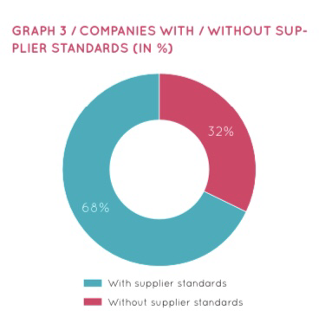
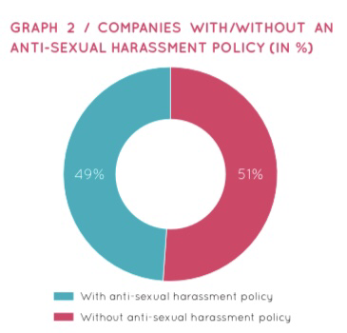
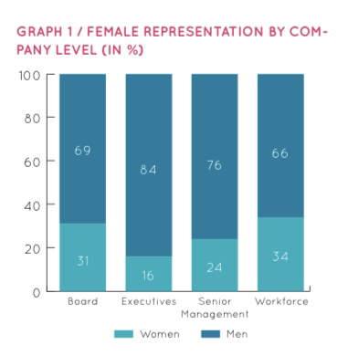
In 2016 the United Nations Committee on the Elimination of Discrimination against Women pointed out to the absence of a national policy or strategy for the implementation of the provisions of the Convention on the Elimination of All Forms of Violence against Women in the Netherlands. Strengthening the implementation of the gender mainstreaming strategy at al levels of government was recommended by the Committee. Netherlands was scored 77.3 out of 100 by the Gender Equality Index of EU in 2022.

Ending the discrimination, mobbing and inequality based on gender is possible with policies that strictly inhibits these activities. Educating people could also a effective way to stop inequality. To actualize that goverments should cooperate with ministry of education of their country. Likewise international cooperations are necessary. Women should be supported in every area. They should be encouraged to participate in govermental affairs.
REFERENCES:
https://en.wikipedia.org/wiki/Netherlands
https://eige.europa.eu/gender-mainstreaming/countries/netherlands
https://www.nlalumni.nl/medias/editor/files/gender-equality-in-the-netherlands.pdf
https://equileap.com/wp-content/uploads/2021/10/Equileap_DutchReport_2021.pdf
https://www.dutchdevelopmentresults.nl/2019/theme/womens-right-and-gender-equality
https://www.government.nl/topics/gender-equality
https://eige.europa.eu/gender-equality-index/2021/country

