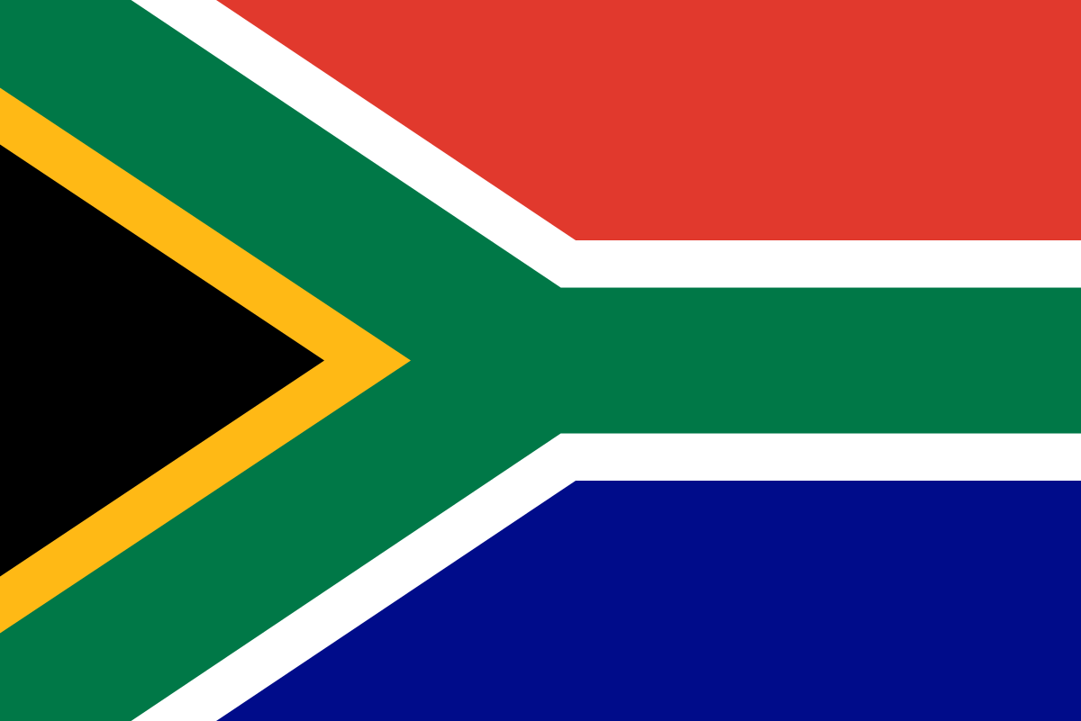
Country: South Africa
Commitee: UNWOMEN
Agenda Item: Gender Related Mobbing

South Africa , officially the Republic of South Africa (RSA) , is the southernmost country in Africa. It is bounded to the south by 2,798 kilometres (1,739 mi) of coastline that stretch along the South Atlantic and Indian Oceans. It borders Namibia to the northwest, Botswana to the north and Zimbabwe, Mozambique ,Eswatini to the northeast. South Africa which has 3 capitals( Pretoria, Cape Town, Bloemfontein) is a member of UN , AU, the Commonwealth of Nations. South Africa has eleven official languages ( English , Afrikaans and nine ethnic languages).the country’s population is 60 million citizens. The Republic of South Africa was constituted on 31 May 1961 and became a constitutional democracy in 1994.

Non-discrimination was a key aspect of South Africa’s first democratically elected government in 1994, which officially adopted a “gender-equality” stance on decreasing discrimination. Since then, South Africa has aimed to end all forms of discrimination, including gender discrimination. Withal, South Africa adopted CEDAW and the Beijing Platform for Action during the 1995 World Conference on Women in Beijing to take steps to eradicate gender discrimination.

South Africa has been performing well in various global and regional indexes that measure gender development and inequality. In 2020, the country achieved a UNDP Gender Development Index score of 0.986 compared to the global value of 0.9439. In 2019, the Mo Ibraham Governance Index ranked South Africa in the top ten highest scoring countries (6th) with a score of 65.8 out of 100.010. The Index’s gender dimension scores South Africa 50.5 against an average of 50.2 on the continent.
The Africa Gender Index (AGI) 2019 shows that the southern Africa sub-region has the least gender inequality on the continent. South Africa’s overall rank is only second to that of Namibia which had the least inequality on the continent according to the AGI 2019. When interpreting the index scores, a score of 1 represents parity between women and men, a score between 0 and 1 means that there is gender inequality in favor of men and a score of higher than 1 means there is gender inequality in favor of women.

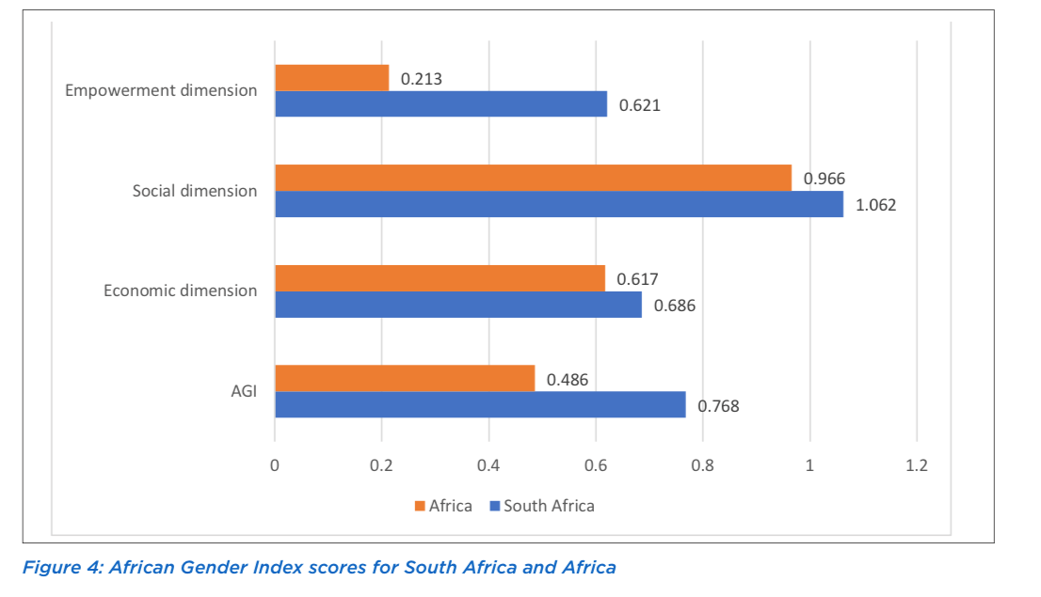
South Africa has made significant progress in the representation of women across Government. In June 2019, 50% of cabinet ministers and 42.9% of deputy ministers were women. Nearly half of parliamentary seats are occupied by women. According to this statistic, the number of women in government in South Africa at that time was higher than in most countries in the world.

The country strives to increase gender equality in social, political, educational and economic life. According to the current situation, South Africa is trying to increase the place of women in the economic and educational life of the country. Innovations are needed for women to gain independence in business and marriage life in the country.

References
https://data.unwomen.org/publications/south-africa-national-gender-statistics-assessment
https://www.sciencedirect.com/science/article/abs/pii/S0277539500001606
https://en.wikipedia.org/wiki/South_Africa
https://evaw-global-database.unwomen.org/en/countries/africa/south-africa?formofviolence=33551dc0667d4610b557c142b729c2a5
https://en.wikipedia.org/wiki/History_of_women%27s_rights_in_South_Africa
https://www.afdb.org/en/documents/africa-gender-index-report-2019-analytical-report

