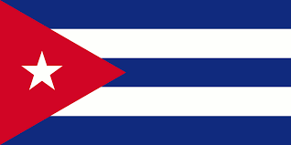
Commitee: WHO
Agenda Item: Legalization of Euthanasia
Country: Cuba
Delegate: Selen Irmak Onar

We , as the delegation of the republic of Cuba are an island country in the Caribbean with over 11 millon inhabitants . Havana , our capital , is also our largest city . The second largest city is Santiago de Cuba . We are the 105th largest country in the world .

We think that euthanasia shouldn't be legal . Human life matters and no matter what, it should be protected unlike the common opinion . Euthanasia is not an individual right ; it is something people can resort to when they are desperate .

We will stand by our decisions and our laws to reduce or end euthanasia . World deserves to be a better place and we are the key to it . Death shouldn't be seen as a salvation and everyone should be able to live well in the time they have been given

