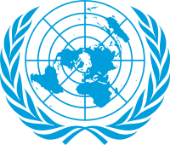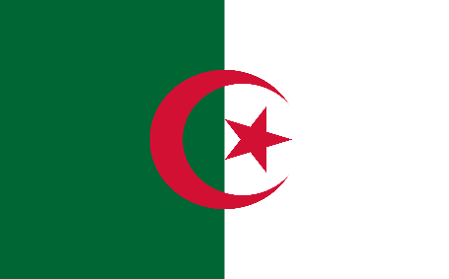
Commitee: WHO
Agenda Item: Legalization of Euthanasia
Country: Algeria
Delegate: Yaren ARSLANOĞLU
Algeria is the largest country in Africa with an area of 2,381,741 km². It has 48 cities and the capital is Algiers. With the French conquest of Algeria in 1830, Algeria became a colony. Algeria resisted colonialism with its entire being. Despite torture, exile and massacres, this resistance resulted in independence. After a long colonial period, Algeria became an independent country in 1962. Algeria joined the United Nations on October 8, 1962. More than %99 of population is Muslim. Algeria's constitution grants freedom of religion to all citizens.
Euthanasia is intentionally ending life to eliminate pain and suffering. Euthanasia is divided into active euthanasia and passive euthanasia. In active euthanasia , there is a direct application. The lethal substance is administered directly to the patient for whom salvage treatment is impossible. In passive euthanasia, there is an indirect application, the machines that keep the patient alive are turned off or the administration of drugs for temporary partial treatment is stopped and no treatment is applied other than the relief of pain.
Legazlization of euthanasia is complicated. There is not a “right to die” under international law but some countries it is legal. In Islam only Allah can take the life given by Allah. Epecially because of this reason we don’t believe it should be legal.

