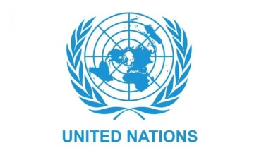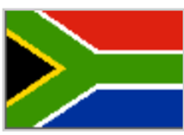
Country: South Africa
Committee: United Nations Development Programme (UNDP)
Agenda Item: Sustainable Development Goals 8 & 9
Delegate: Elifnaz Taş

Our country, The Republic of South Africa (RSA) is the second-most populous country located entirely south of the equator, after Tanzania. South Africa has three capital cities, with the executive, judicial and legislative branches of government based in Pretoria, Bloemfontein, and Cape Town respectively. We have a multiethnic society encompassing a wide variety of cultures, languages, and religions. 11 official languages are recognized by the constitution.We have a significant regional influence are a member of both the Commonwealth of Nations and the G20.We are a developing country, ranking 109th on the Human Development Index, the 2nd highest in Africa. We have been classified by the World Bank as a newly industrialised country and have the third-largest economy in Africa and the most industrialized, technologically advanced economy in Africa overall as well as the 33rd-largest in the world.

We, as a South African country, are a developing country and we are working on this to continue. No matter how much work we have done, there are still issues that we cannot find a solution for, such as hunger and equality between men and women. But thanks to our work on these issues, we are developing it further. We are working to eliminate these problems in our country. We are carrying out many projects that will develop the country, for the development of the infrastructure, for economic growth and so on. We want and work to be a country where our sustainable development goals are realized in a better world in 2030.

Significant progress on our developmental journey since the advent of democracy in 1994: The country is therefore well placed towards meeting the SDGs. The NDP has contributed to improved living conditions for millions of South Africans in a context where, for historical reasons, South Africa is amongst the most unequal of societies.
Progress in critical areas such as the provision of clean water, electricity, sanitation, education and health: Access to free education for children from poor households has been expanded - over 9 million children attend no-fee schools. Individuals benefiting from the social protection system increased: from 3 million in 1994 to 17,5 million in 2018. South Africa has the biggest anti-retroviral treatment programme in the world - over 4.5 million people. Inclusive growth is being accelerated by increasing levels of investment and measures to create more jobs.
Other highlights of progress:
Major strides in addressing gender inequalities: Legislative frameworks have been developed aimed at ending all forms of discrimination against women and girls. Representation of women in national parliament has increased: 25% in 1994 to 41% in 2016. Approximately 35% of permanent judges are women.

